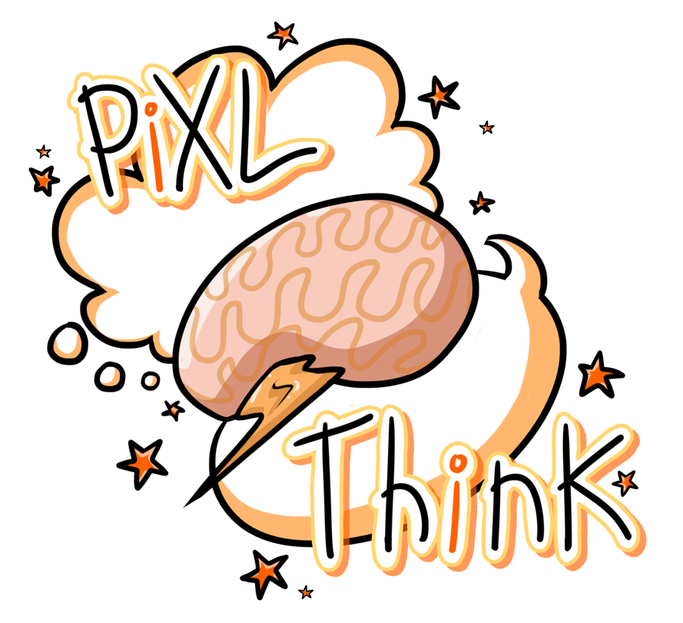

PiXL Revisit
A Strategy for Revision

© Commissioned by The PiXL Club Ltd. April 2018

PiXL Revisit – a strategy for revision.
The increased complexity and content of the newly reformed GCSE and A Level exams means that effective revisiting is essential if our students are to achieve academic success.
As teachers, our capacity is already stretched to limit, ensuring that content and skills are covered during curriculum time. Our evenings are often busy with intervention and therapy sessions to consolidate knowledge and to prepare students as fully as possible for the rigour of their exams. We teach, challenge, assess, feedback, and intervene in the hope that our guidance will get them through. However, there is a time every year when we must leave our students to their own devices. We must let them go… armed only with their revision guides, some general advice and some well wishes.
Our main concern, for some pupils, is whether they will actually revise enough in the time they have left. Our second concern is whether the methods they use to revisit will be effective. We certainly don’t want our students expending energy and time studying in a way that produces no fruit.
So how can we ensure our students are working effectively outside of the classroom? What does good revisiting look like? The newly reformed exams mean that students will have to recall greater amounts of facts and knowledge quickly. While rote learning and regurgitating content doesn’t lead to deep thinking, we know that firstly the information needs to go in, through memorisation of key facts. Fundamental knowledge needs to be embedded, even imprinted on the minds of students to facilitate quick and easy recall. Next students need to deepen their knowledge through higher-order thinking as information learned and processed through higher-order thinking processes is remembered longer and more clearly than information that is processed through lower-order, rote memorisation. Finally, students need to retrieve, demonstrate, apply and test their learning.
PiXL Revisit is a simple revisiting method that ensures students are preparing for external exams in an effective way. It is based on the three key stages explained above and is arranged around a 10 week cycle.
- Stage 1 - Upload - Embedding the knowledge.
- Stage 2 - Process - Deepening the knowledge.
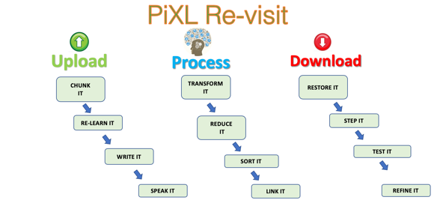
- Stage 3 - Download - Demonstrating the knowledge.
The strategy comes with a clear and simple methodology as well as revisiting templates to organise the learning. A learning schedule is also provided which can be dictated by the teacher or planned by the students.
This pack contains templates we have produced to embed the “Thinking Hard” devices and use them in the PiXL Revisit Strategy. It also includes a calendar to enable our students to be more independent in their revision. This is most effective when used by individual subjects to ensure that revision is targetted and precise. In the pack we have also included BLANK sheets and sheets with instructions.
The methodolgy of PiXL Revisit is described in more detail in the breakout slides. We hope this is useful in enabling students to engage with and think deeply about the material they are revisiting and by doing this embed it into their memory.
The PiXL Thinking Hard Team

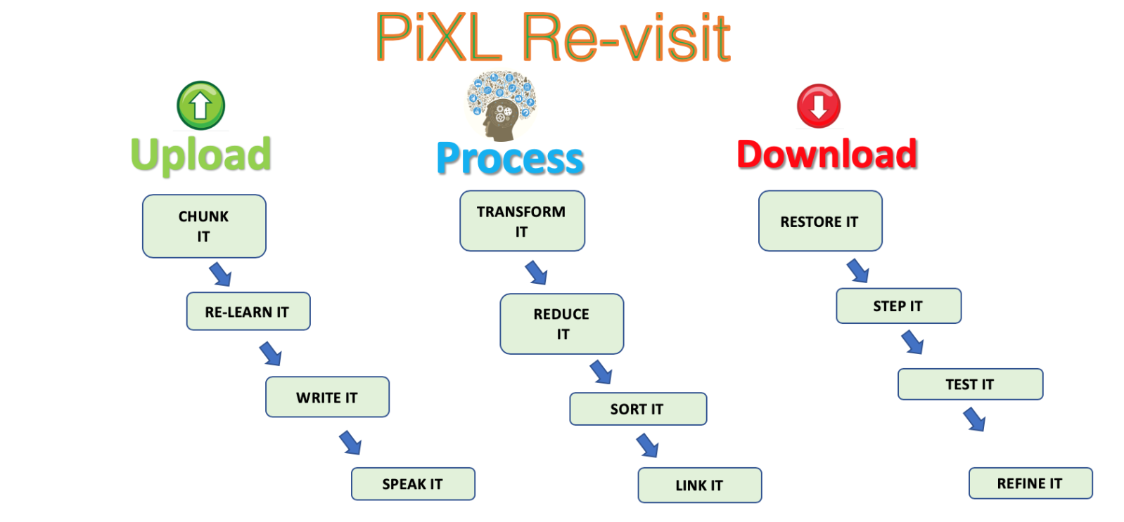

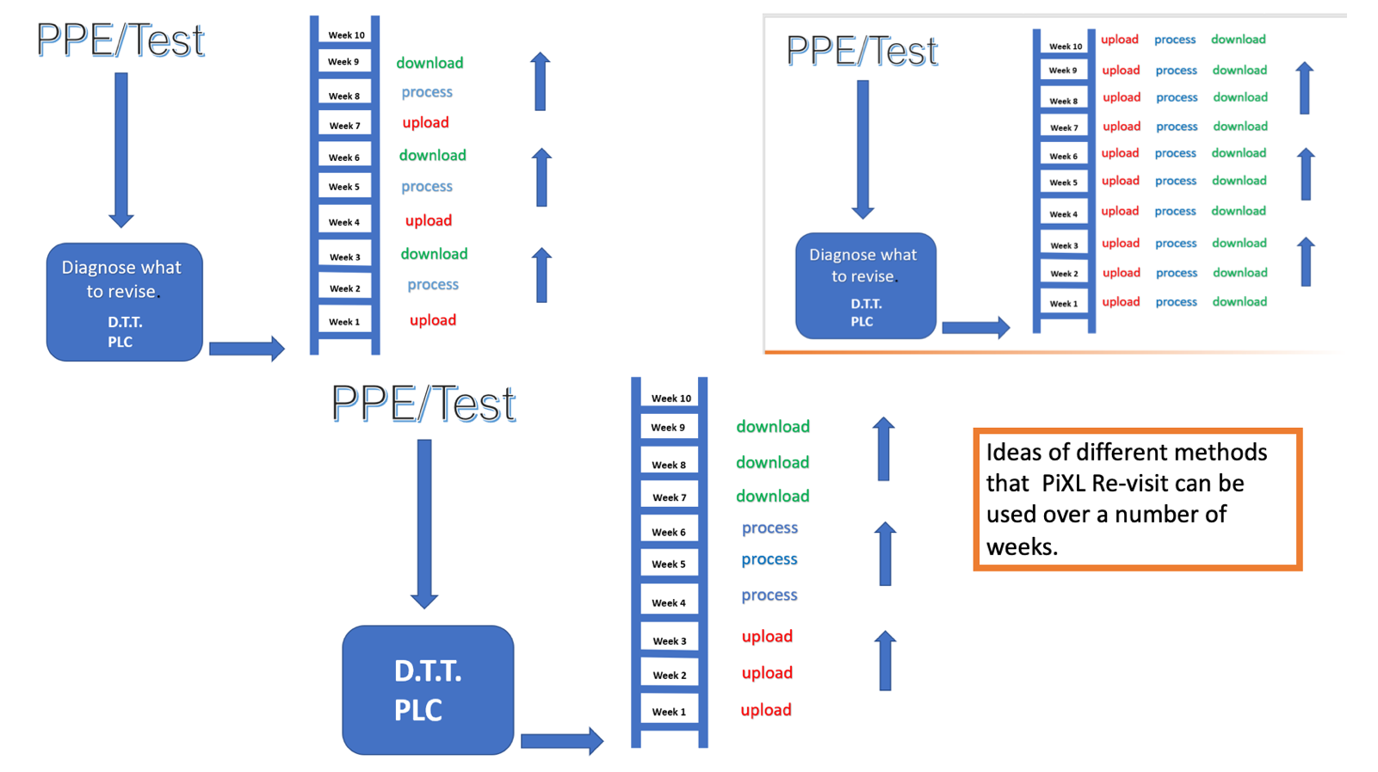

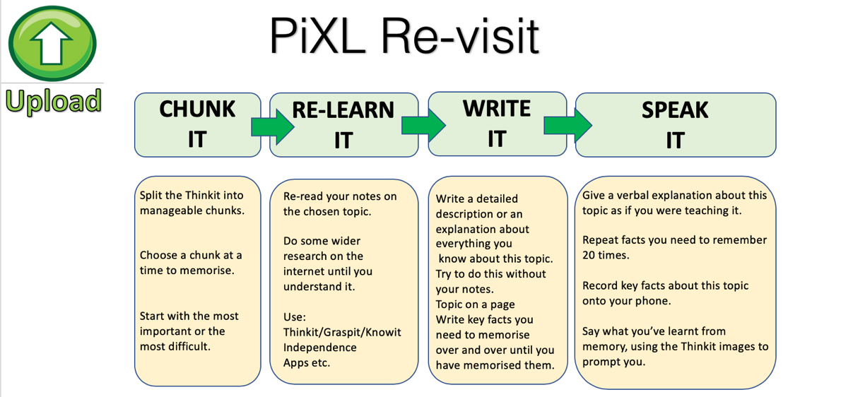

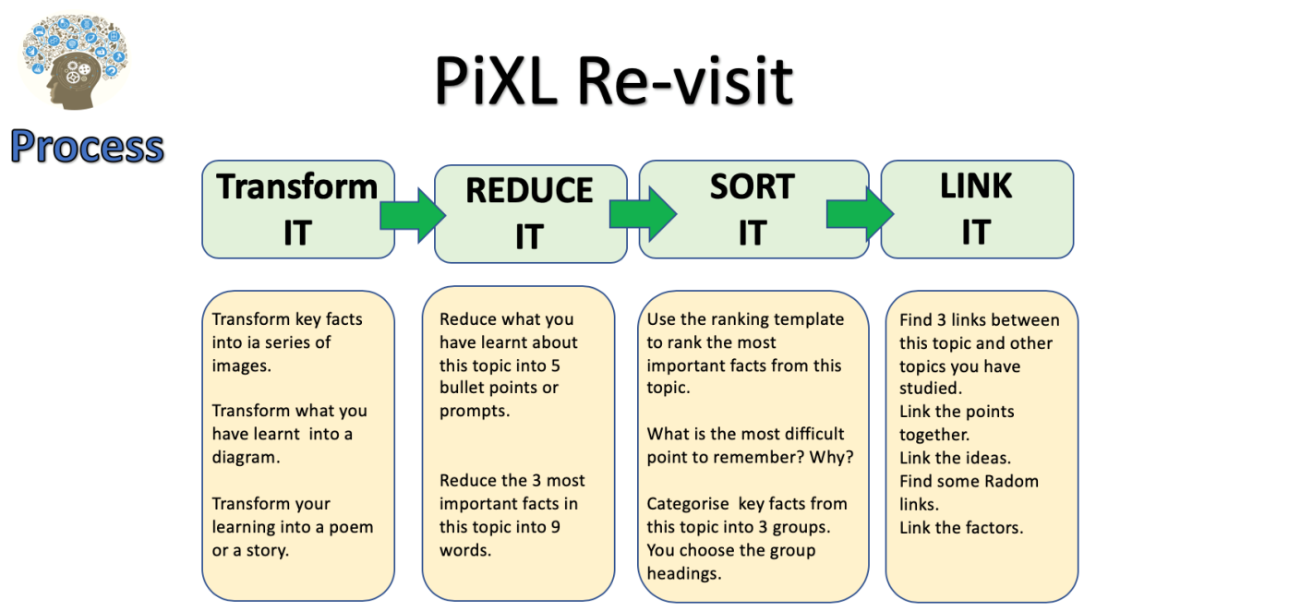

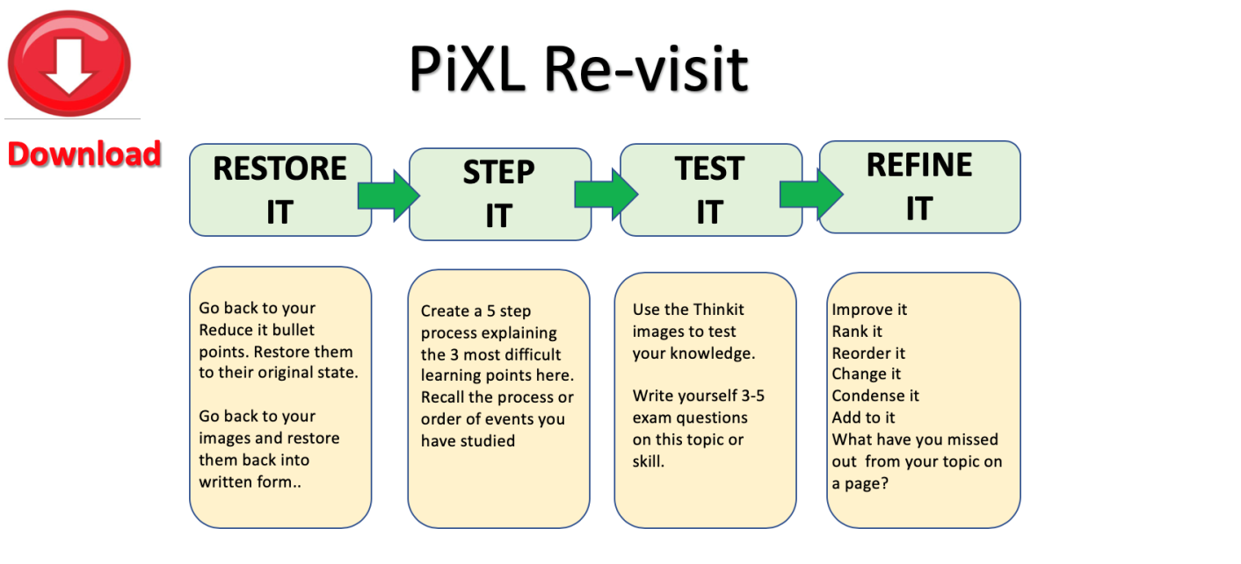

PiXL Revisit: Reduce and Transform
Unit / Topic:

1.

2.

3.

4.

5.

Unit / Topic:
PiXL Revisit: Prioritise - Significance and Importance
5.

3.

1.
Notes:

WHY?

WHY?
Key Facts, Dates, Words, Vocab:
Number of Priority:

WHY?

WHY?
2.

4.

WHY?

PiXL Revisit: 3 x 2 Testing
Unit / Topic:

Last Lesson
Key facts:
Last Week
Key facts:
Last Year
Key facts:
One topic to revise next:

PiXL Revisit: Process and Categorise
Steps and stages explained

Unit / Topic:

Which is the most important stage?

WHY?

Key Facts / Observations

PiXL Revisit: Chunk It
Unit / Topic:

10
Chunks of learning of this / topic / area
* You could start with the most important or the most difficult to learn

1.
2.
3.
4.
5.
6.
7.
8.
9.
10.

PiXL Revisit: Ranking Triangle

Name of Topic: __________________________________________________________________________________________________
Name: __________________________________________________________________________________________________
Class: __________________________________________________________________________________________________

The most important information goes at the top and then the least important at the bottom. Make sure you justify WHY you think it the most/least important.

_______________________________________________________________________________________________________________________________________________________________________________________________________________________________________________________________________________________________________________________________________________________________________________________
PiXL Revisit: Thinking Hard Model

Name of Topic: __________________________________________________________________________________________________
Name: __________________________________________________________________________________________________
Class: __________________________________________________________________________________________________

Take a section of the text and do the following:

- Prioritise: Underline the three most important sentences here. Rank 1-3, briefly explain number 1. Cross out the least important sentence

- Reduce: Reduce the key information into 12 words

- Transform: Transform this information into 4 pictures or images (no words allowed)

- Categorise: Sort this information into three categories. Highlight and think of a suitable title for each category.

- Extend: Write down three questions you’d like to ask an expert in this subject.

PiXL Revisit: ‘Boxing Up’ Activity

Name of Topic: __________________________________________________________________________________________________
Name: __________________________________________________________________________________________________
Class: __________________________________________________________________________________________________

Read the text and then put your thoughts in to different boxes so that you have ‘boxed up’ the text.

Box 1 – 3 things I did not know

Box 2 – 3 things I understand better now

Box 3 – 3 things I already knew

PiXL Revisit: Question Time

Name of Topic: __________________________________________________________________________________________________
Name: __________________________________________________________________________________________________
Class: __________________________________________________________________________________________________
When you read any text, you should be asking it questions NOT just letting it wash over you. Read your text and pause and ask it questions - e.g. ‘what do you mean when you say ‘….”?’

Questions I’m asking the text |  | Answers to those questions |  | Things I need to ask my teacher
PiXL Revisit: Quizzing

Name of Topic: __________________________________________________________________________________________________
Name: __________________________________________________________________________________________________
Class: __________________________________________________________________________________________________
Read the text and come up with 20 questions to ask someone about the text.
 | Question | Answer
1
2
3
4
5
6
7
8
9
10
11
12
13
14
15
16
17
18
19
20

PiXL Revisit: Transforming

Name of Topic: __________________________________________________________________________________________________
Name: __________________________________________________________________________________________________
Class: __________________________________________________________________________________________________
Turn the material you have read into up to 6 pictures – one per paragraph or one per key piece of information. The pictures must represent the information so that they can act as a reminder of what the text said. Underneath each picture, explain your thinking.

1. | 2. | 3.
4. | 5. | 6.

Now restore your pictures back into its original form.

Chapter theme / topic
Main idea 1
Specific detail A
Specific detail B
Specific detail C
Main idea 2
Specific detail D
Specific detail E
Specific detail F
Specific detail G
Specific detail H
Specific detail I
Specific detail J
Specific detail K
Specific detail K
Main idea 4
Main idea 3

Taken from the article: ‘What Will Improve a Student’s Memory?’ By Daniel T Willingham (http://www.aft.org/sites/default/files/periodicals/willingham_0.pdf)

Taken from the article: ‘What Will Improve a Student’s Memory?’ By Daniel T Willingham (http://www.aft.org/sites/default/files/periodicals/willingham_0.pdf)
PiXL Revisit: Transform
Unit / Topic:

Key Points

1.
2.
3.
4.
5.
6.
7.
8.
9.
10.

PICTURE/ SOURCE/ INFO/ RESOURCE

Most important + WHY:

PiXL Revisit: Examine It

Key Dates
Exam Question
NOTES
Topic:
1.
2.
3.
4.
5.
6.
Key Facts
Key Quotes
Key Formulae
Key Words

PiXL Revisit: Flexibility of thinking Connection Map

Title

PiXL Revisit: Flexibility of thinking Connection Map
Draw lines linking the boxes. The darker /stronger the line the stronger the link.
Title
Place the information/ factors/knowledge in the boxes. Add as many boxes as you want to.

On the line give reasons for the links - explain the LINK /importance or significance.

You could also add formula/dates/facts/quotes near or on the line to exemplify knowledge

PiXL Revisit: Experiment on a page
Experiment Title:

Process / Method

1.
2.
3.
4.
5.
6.
7.
8.
9.
10.

Formulae
Label
Label
Label
Experiment Diagram
Results

PiXL Revisit: Transform
Unit / Topic:
Picture
NOTES:

Picture

PiXL Revisit: Reduce to 6 points
Unit / Topic:

Information

Information
Reduce to 6 points

1.
2.
3.
4.
5.
6.
Prioritise (most important)

1.
2.
3.
4.
5.
6.

WHY?
P
R
I
O
R
I
T
I
S
E

Reduce to 3 key points

A.

B.

C.
R
E
D
U
C
E

Monday | Tuesday  PiXL Revisit: Chunk It Revision Timetable, March - April | Wednesday | Thursday | Friday
25th March  Not sure OK Great!  I must recap:  Page number: | 26th March  Not sure OK Great!  I must recap:  Page number: | 27th March  Not sure OK Great!  I must recap:  Page number: | 28th March  Not sure OK Great!  I must recap:  Page number: | 29th March  Not sure OK Great!  I must recap:  Page number:
1st April  Not sure OK Great!  I must recap:  Page number: | 2nd April  Not sure OK Great!  I must recap:  Page number: | 3rd April  Not sure OK Great!  I must recap:  Page number: | 4th April  Not sure OK Great!  I must recap:  Page number: | 5th April  Not sure OK Great!  I must recap:  Page number:
8th April  Not sure OK Great!  I must recap:  Page number: | 9th April  Not sure OK Great!  I must recap:  Page number: | 10th April  Not sure OK Great!  I must recap:  Page number: | 11th April  Not sure OK Great!  I must recap:  Page number: | 12th April  Not sure OK Great!  I must recap:  Page number:
15th April  Not sure OK Great!  I must recap:  Page number: | 16th April  Not sure OK Great!  I must recap:  Page number: | 17th April  Not sure OK Great!  I must recap:  Page number: | 18th April  Not sure OK Great!  I must recap:  Page number: | 19th April  Not sure OK Great!  I must recap:  Page number:
PiXL Revisit: Chunk It Revision Timetable, April
PiXL Revisit: Chunk It Revision Timetable, April - May

Monday | Tuesday | Wednesday | Thursday | Friday
22nd April  Not sure OK Great! | 23rd April  Not sure OK Great! | 24th April  Not sure OK Great! | 25th April  Not sure OK Great! | 26th April  Not sure OK Great!
29th April  Not sure OK Great!  I must recap:  Page number: | 30th May  Not sure OK Great!  I must recap:  Page number: | 1st May  Not sure OK Great!  I must recap:  Page number: | 2nd May  Not sure OK Great!  I must recap:  Page number: | 3rd May  Not sure OK Great!  I must recap:  Page number:
6th May  Not sure OK Great!  I must recap:  Page number: | 7th May  PiXL Revisit: Chunk It Revision Timetable, May  Not sure OK Great!  I must recap:  Page number: | 8th May  Not sure OK Great!  I must recap:  Page number: | 9th May  Not sure OK Great!  I must recap:  Page number: | 10th May  Not sure OK Great!  I must recap:  Page number:
13th May  Not sure OK Great!  I must recap:  Page number: | 14th May  Not sure OK Great!  I must recap:  Page number: | 15th May  Not sure OK Great!  I must recap:  Page number: | 16th May  Not sure OK Great!  I must recap:  Page number: | 17th May  Not sure OK Great!  I must recap:  Page number:
20st May  Not sure OK Great!  I must recap:  Page number: | 21st May  PiXL Revisit: Chunk It Revision Timetable, May  Not sure OK Great!  I must recap:  Page number: | 22nd May  Not sure OK Great!  I must recap:  Page number: | 23rd May  Not sure OK Great!  I must recap:  Page number: | 24th May  Not sure OK Great!  I must recap:  Page number:
27th May  Not sure OK Great!  I must recap:  Page number: | 28th May  Not sure OK Great!  I must recap:  Page number: | 29th May  Recap everything you need to for Paper x.  Not sure OK Great!  What do you need to re-cover? | 30th May  Recap everything you need to for Paper x.  Not sure OK Great!  What do you need to re-cover? | 31st May  Recap everything you need to for Paper x.  Not sure OK Great!  What do you need to re-cover?
3rd June  Recap everything you need to for Paper x.  Not sure OK Great!  What do you need to re-cover? | 4th June  Recap everything you need to for Paper x.  Not sure OK Great!  What do you need to re-cover? | 5th June  Recap everything you need to for Paper x.  Not sure OK Great!  What do you need to re-cover? | 6th June  Recap everything you need to for Paper x.  Not sure OK Great!  What do you need to re-cover? | 7th June  Recap everything you need to for Paper x.  Not sure OK Great!  What do you need to re-cover?
10th June  Recap everything you need to for Paper x.  Not sure OK Great!  What do you need to re-cover? | 11th June  Recap everything you need to for Paper x.  Not sure OK Great!  What do you need to re-cover? | 12th June  Recap everything you need to for Paper x.  Not sure OK Great!  What do you need to re-cover? | 13th June  Recap everything you need to for Paper x.  Not sure OK Great!  What do you need to re-cover? | 14th June  Recap everything you need to for Paper x.  Not sure OK Great!  What do you need to re-cover?
PiXL Revisit: Chunk It Revision Timetable, June

17th June  Recap everything you need to for Paper x.  Not sure OK Great!  What do you need to re-cover? | 18th June  Recap everything you need to for Paper x.  Not sure OK Great!  What do you need to re-cover? | 19th June  Recap everything you need to for Paper x.  Not sure OK Great!  What do you need to re-cover? | 20th June  Recap everything you need to for Paper x.  Not sure OK Great!  What do you need to re-cover? | 21st June  Recap everything you need to for Paper x.  Not sure OK Great!  What do you need to re-cover?
24th June  Recap everything you need to for Paper x.  Not sure OK Great!  What do you need to re-cover? | 25th June  Recap everything you need to for Paper x.  Not sure OK Great!  What do you need to re-cover? | 26th June  Recap everything you need to for Paper x.  Not sure OK Great!  What do you need to re-cover? | 27th June  Recap everything you need to for Paper x.  Not sure OK Great!  What do you need to re-cover? | 28th June  Recap everything you need to for Paper x.  Not sure OK Great!  What do you need to re-cover?
PiXL Revisit: Chunk It Revision Timetable, June

© Commissioned by The PiXL Club Ltd. April 2018

This resource is strictly for the use by The PiXL Club Ltd member schools during the life of the membership only. It may NOT be copied, sold, or transferred or made available by whatever means to a third party non-member during or after membership. Until such time it may be freely used within the PiXL member school by their teachers and authorized staff and any other use or sale thereof is strictly prohibited.

All opinions and contributions are those of the authors. The contents of this resource are not connected with, or endorsed by, any other company, organisation or institution.

PiXL Club Ltd endeavour to trace and contact copyright owners. If there are any inadvertent omissions or errors in the acknowledgements or usage, this is unintended and PiXL will remedy these on written notification.

