Years 7, 8 and 9 Art Suggestions Working from home
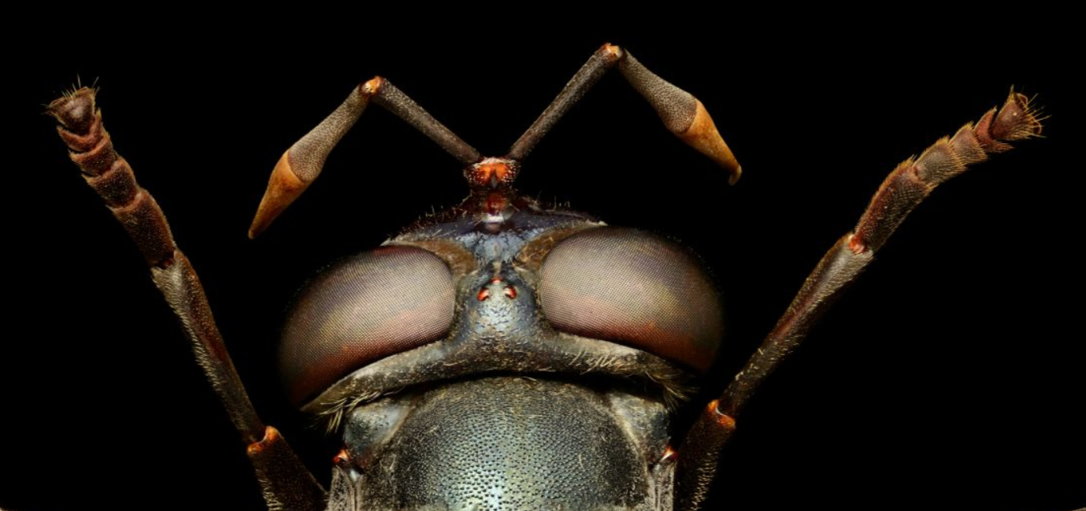

Go to this website: Microsculpture. Watch the video. Click on the word ‘Explore’ in the top left-hand corner. Click on an insect. Zoom in to see the amazing detail. Spend 10 minutes exploring the different insects. On paper, draw an insect or close-up of an insect. If you have coloured pencils you can create your drawing in colour.

Go to The Tate website and spend 5-10 minutes looking at what exhibitions are on. Choose an exhibition that looks interesting to you. On paper, write about the exhibition you have discovered. The title of your piece of writing can be the name of the exhibition. Explain if it features one or more artists. Write what sort of work the artist(s) creates and if the exhibition is about all of the artists’ life or has a special focus. Explain why you chose this exhibition in particular. Google the artists name to see more of their work which will give you a deeper insight into the artist. What else can you discover? If you have access to a printer at home you can add pictures too.

Go to the Google Arts & Culture website. Click on ‘Explore’ and then ‘Artists’. Spend 10 minutes exploring the different artists featured there. When you click on an artist you need to scroll down to see examples of their work. Choose an artist that you like the look of. On paper, write about the artist you have chosen. Their name can be the title of your work. Describe what their work is like. (Is it a painting or sculpture or something else) Describe it in details and try to find out what media the artist uses e.g. oil paint or charcoal. Research further on the internet and see what you can find out.

PHOTOGRAPHY

- CLOSE UPS
Use your mobile phone or an iPad to take a selection of close-up photographs around your home or garden. Try getting very close to objects. Think about unusual angles and perspectives. What different viewpoints do you get if you crawl around the room? What great photographs could you take if you look inside objects, or lights or drawers? How can you make every-day objects look different or unusual by taking close-up photographs or cropping photographs? Take at least 30 photographs and then select your best 9. Either use an App such as Pic Collage which allows you to put your photographs in a grid, or print them and present them on paper.
Draw your favourite 3 close-up photographs.

- Photographic Textures
Use your mobile phone or an iPad to take a selection of photographs around your home or garden that have texture. Often when you get up close to wood, wicker, bark, carpet, clothing or other objects you can see the texture of their surface. Take at least 30 photographs and then select your 9 best photographs that have an amazing texture. Either use an App such as Pic Collage which allows you to put your photographs in a grid, or print them and present them on paper.
Draw your favourite 3 textural photographs.

- Photographic Diary
This art activity is going to be spread throughout the day as your task is to create a photographic diary. You can use a phone, iPad or camera to do this, but please think carefully about how you will present this. This diary will have no words because, as the saying goes ‘A picture speaks a thousand words’. You might want to focus on the environment around you. (Buildings, interiors, gardens) Or your photographic diary might be all about the people in your day. Be as creative as you like. Either use an App such as Pic Collage which allows you to put your photographs in a grid and present them on a page, or print them, cut them out and present them on paper.

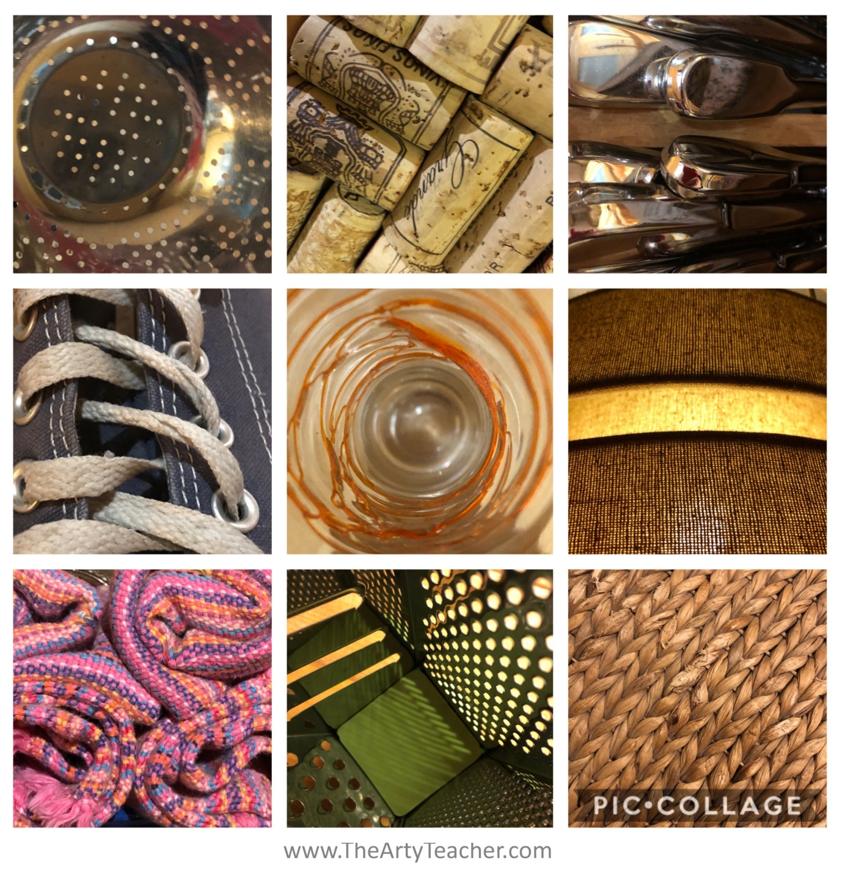

Look at the artwork of Giulia Bernardelli. She paints pictures with coffee. Mix up some strong instant coffee so that it is really dark. Using a spoon or a variety of tools you can find in the kitchen, paint a picture with coffee. Bernardelli lets the coffee spill onto the page and then sees what it reminds her of. You can take this approach or you can find an image on the internet to work from.

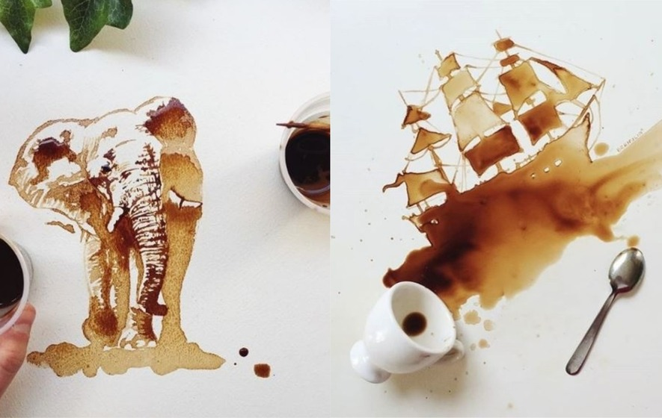

Drawing Suggestions
A close up of your pet.
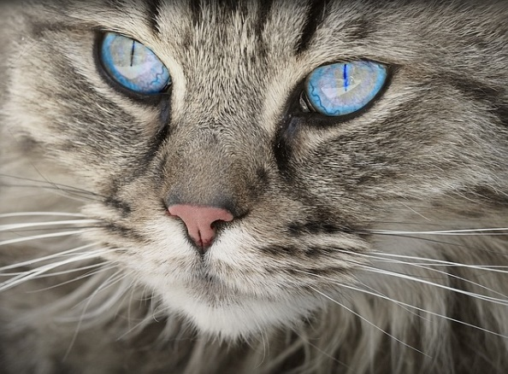
Glasses
A houseplant
A cup and saucer
Eyes. Your own, a friend’s or a family member.
Something that is woven.
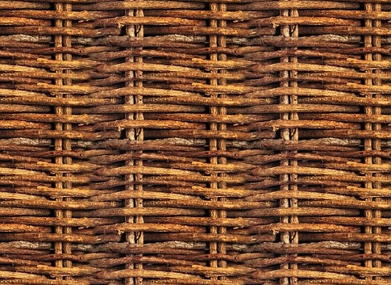
The clothes you dropped on the floor.
Your unmade bed.
A rose.
Your headphones.
A stack of books.
A smile.
The view from your window.
A vase of flowers.
Some old shoes.

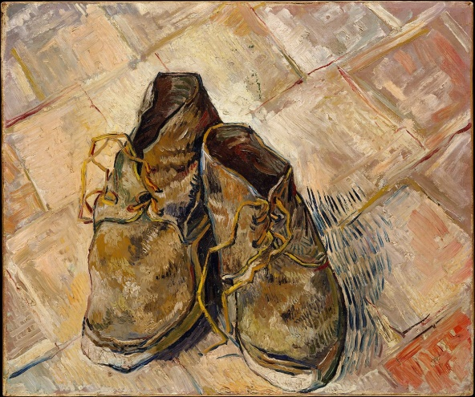
A bunch of keys.
A nose.
A fingertip.
A banana peel.
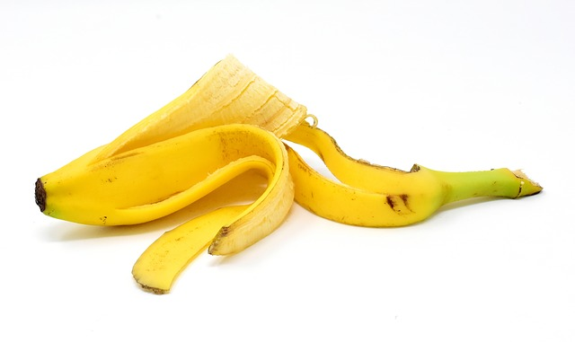
A pile of magazines or newspapers.
A glass of water.
Your bookshelf.

A single biscuit or an open packet of Oreo’s for example.
The view through a keyhole.
An eyeshadow palette.

Art and Design Quiz can be found here
https://www.educationquizzes.com/ks3/art-and-design/

