Assessment tracking DWR
Content
Assessment | Assessment Grade | Development point
Key Question 1: What were the main causes of the Depression?
Key Question 2: How were people able to cope with the challenges of the Depression years?
Key Question 3: How effectively did Britain prepare for war?
Key Question 4: How did people in Britain cope with the experience of war?
Key Question 5: How important was it to maintain people's morale during the war?
Key Question 6: How difficult were conditions in Britain in 1945?

Key Question 7: How did the Labour government deal with the problems of the time?

EXAM QUESTIONS
SKILLS
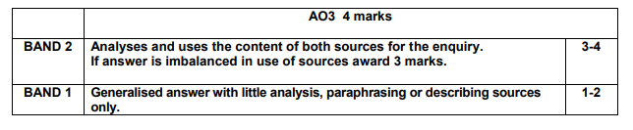
Qu 1
Question 1: What can be learnt from Sources A and B about …………..
This is only source analysis (A03). No extra context is needed.
Describe 2 points from each source.
Spend 4 mins on this question!
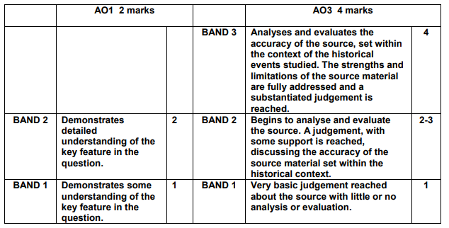
Qu 2
Question 2: To what extent does this source accurately explain …
Spend 5 mins on this question.
It will always be a ‘to what extent’ question.
- Need to give strengths and limitations of the source.
- Focus on accuracy.
- Focus on the authorship.
- Must include a judgement.
- BALANCED ANSWERS

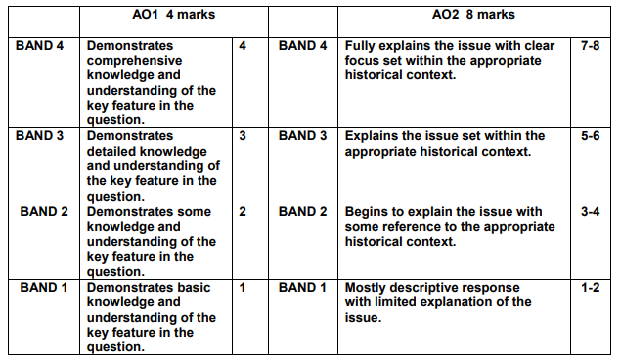
Qu 3
Question 3: Why was the ………………………….. significant to Britain?
Spend 10 minutes on this question.
Explain SIGNIFICANCE!
Do not say it is not significant.
3 Reasons it is significant/important.

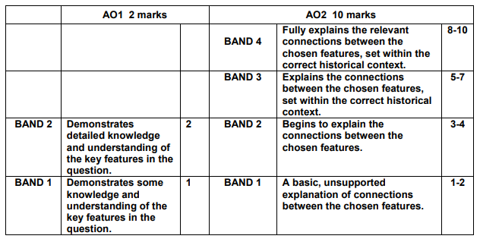
Qu 4
Question 4: Explain the connections between any THREE of the following:
Do all 3. And add what connects them!
Use these words: caused, led to, effect, affect, prompted, resulted in, subsequently.

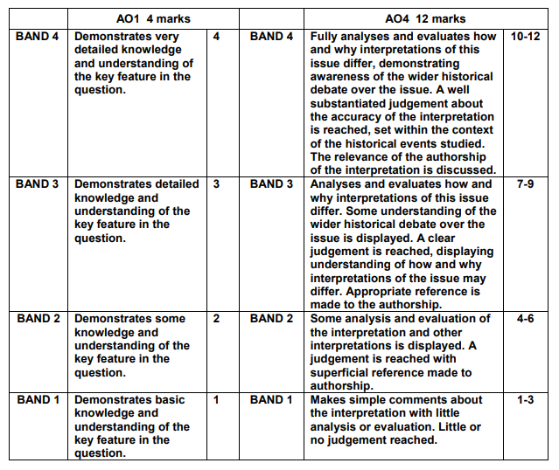
Qu 5
Question 5: Read the interpretation below and then answer the question which follows. How far do you agree with this interpretation of the reasons why the …………?
[In your answer you should refer to how and why interpretations of this issue differ. Use your own knowledge and understanding of the wider historical debate over this issue to reach a wellsupported judgement.]
This questions links to the wider historical debate.
It will be focused on HOW and WHY interpretations are formed.
Look at COP.
CONTENT - what does it say?
ORIGIN – where is it from, who wrote it?
PURPOSE – why was it written
Is it a VALID point?
It will be a secondary source

Depression, War & Recovery (1930-1951) Revision
Key Question 1: What were the main causes of the Depression?
Unlike the USA there was no long lasting boom in Britain after WW1 in the 1920s. This meant that for 20 years after WW1 the people of Britain largely struggled in their daily lives. An important reason for this was the decline in traditional industries as a result of the war.
Coal
List reasons why the coal industry became a lot less profitable in the 1930s

Name two other similar industries that also suffered like coal.

How did the US Wall Street Crash affect Wales and England?

Name some areas in Wales and England where the ‘Depression’ had hit the most. Why had they been particularly hit?

Brainstorm the causes of the Depression.

Grade:

Key Question 2: How were people able to cope with the challenges of the Depression years?
What were UAB’s | What was the function of a UAB?
What was the NUWM? | What was the function of the NUWM?
Give examples of how people who lived in Wales & England at this time coped or didn’t cope with how the Depression affected their lives.

The Conservative government did little to help people suffering from the Depression because they were trying to cut public spending. The most important policy they passed was the ‘Special Areas Act’ of 1934.

What was the ‘Special Areas Act’ and what did it do?

Which new industries grew in the 1930s and why did they grow when other industries died out?

Which areas did unemployed workers of England and Wales migrate to in order to find work? | What were their experiences?
Sport and popular entertainment helped people to cope with the Depression. Why were the following so popular?
Rugby

Radio

Cinema

Television

 | What information does Source A give about the Depression?
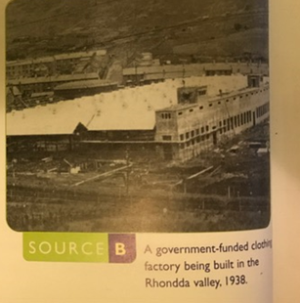 | Use the information in Source B and your own knowledge to explain how the government tried to deal with the Depression.
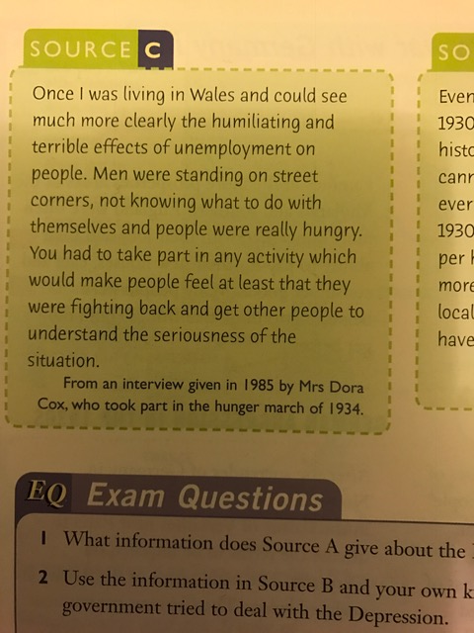 | How useful is Source C as evidence to an historian studying the Depression in Wales? Explain your answer using the source & your own knowledge.
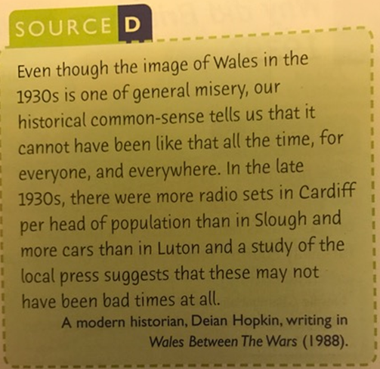 | In Source D the author is saying that in many ways things were improving in Wales during the 1930s. Is this a valid interpretation?  Grade:
Key Question 3: How effectively did Britain prepare for war?
For the twenty years after the Treaty of Versailles the German people were still very resentful over the terms and the fact that they had not been allowed to take part in the peace negotiations. This resentment contributed to the tension which eventually led to the outbreak of the Second World War.
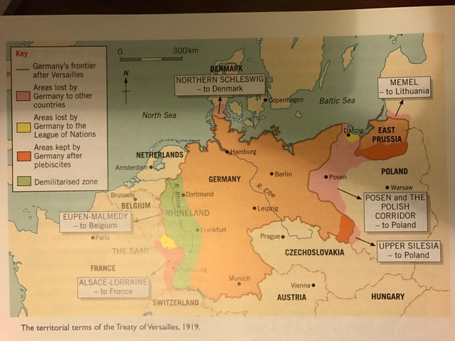

The map above shows the distribution of land in Europe after the Treaty of Versailles. Identify areas that Germany might be resentful about and want back.

Explain how the following contributed to World War 2 breaking out:
Adolf Hitler |  | Treaty of Versailles
The reoccupationation of the Rhineland |  | Austria (Anschluss)
Neville Chamberlain |  | Sudetenland & Czecholslovakia
Munich Agreement |  | Appeasement
What the dates of the following events? (Months are also important in this question)
The Treaty of Versailles

Adolf Hitler became Chancellor of Germany

Reoccupation of the Rhineland

Chamberlain became PM

Anschluss (union) of Austria

Munich Agreement

Sudetenland given to Germany

Invasion of Czecholslovakia

Invasion of Poland

Start of WW2

Describe the steps which Hitler took to achieve the Anschluss.

How did the British people react to the threats of foreign aggression in the 1920s? (What did they do?)

Explain why Neville Chamberlain was forced to resign in 1940.

Explain the events which led to the signing of the Munich Agreement in September 1938?

What was Appeasement? When was this policy in action?

Who supported Appeasement and why did they do this?

What was the Nazi-Soviet Pact? Date?

When did British attitudes towards Germany and a possible war change and for what reasons?

Was Britain ready for war in September 1939?
Yes |  | No
Why did Britain and France sign the Munich Agreement?

Was Chamberlain right or wrong to follow a policy of appeasement? Explain your reasoning.

How important was the Nazi-Soviet Pact in starting the Second World War? Consider other reasons when making your decision.

Explain why Britain accepted the German reoccupation of the Rhineland.

Explain why Britain declared war on Germany in 1939? Explain your answer fully.

Grade:

Key Question 4: How did people in Britain cope with the experience of war?
Key Question 5: How important was it to maintain people's morale during the war?
Explain the preparations that the government put in place immediately as war started.

What was the ‘phoney war’?

Explain the role of Winston Churchill during World War 2.

Describe the early events of the war until France surrendered in June 1940.

Why was Dunkirk seen as victory when it was a defeat for Britain?

What was the Battle of Britain from July to September 1940?

Explain the term Blitz?

Describe the impact of the Blitz on British citizens?

After the Blitz ended what form of air attack did the Germans used on British cities especially London?

Explain the main features of evacuation.

Explain why rationing was introduced.

Explain the following ackronyms
ATS

WRNS

WAAF

What contribution did women make to the war effort?

How important was the role that women played in the war effort?

How did the government maintain the morale of the British people?

Grade:

Key Question 6: How difficult were conditions in Britain in 1945?
Key Question 7: How did the Labour government deal with the problems of the time?
Name 3 Labour politicians who began to plan a better future for Britain whilst the war was still ongoing.

1.

2.

3.

What were five giants refered to in the Beveridge Report?

1.

2.

3.

4.

5.

What were the aims of the Beveridge report of 1942?

What and when was VE-day?

Who became Prime Minister in 1945?

Why did Labour win the General Election of 1945? / Why did the Conservatives lose the General Election of 1945?

Describe the state of Britain at the end of the war in 1945.

What public services were Labour promising to introduce / improve in 1945?

Explain how Labour tackled their ‘Homes for All’ policy in 1945?

How successful were the Labour Government’s housing policies?

What did the National Insurance Act of 1946 introduce?

What was the National Assistance Board set up in 1948?

Explain the aims of Bevan’s National Service Health Bill.

Why were doctors reluctant to be part of the new NHS?

What compromise was given to doctors?

What were the disadvantages of the new NHS?

What were the advantages of the new NHS?

Describe the main features of the 1944 Education Act.

How successful was the Education Act?

What was ‘Nationalisation’?

Why was this policy introduced for some industries?

Give some examples of nationalised industries.

How successful was the Labour government’s nationalisation policy?

By the time of the next General Election many people in Britain felt that things had hardly improved since the end of the war. Give some examples of these problems.

How did the Labour government attack ‘ignorance’?

Why had Attlee’s government lost popularity by 1950?

Describe one of the main domestic policies faced by the Labour government in 1945?

How far had the Labour government’s economic and social policies changed Wales and England by 1951?
Grade:

Explain why Labour’s nationalisation policy was supported AND opposed.

How important was the establishment of the NHS?

Grade:

