How to get an A* in History!
It is easier than you think to get a good grade in history:
- Learn the key facts so you can explain your answers
- Learn how to answer the exam questions.

Essential tips: This paper is only an hour long! You need to practice answering questions fast – the biggest tip I can give you is to learn exactly what the questions want now – so you can plunge into the exam and be efficient.
WJEC say that people will get better marks if they keep adding CONTEXT to their answers. This means what was happening at the time the source was produced and who had produced it. The easiest way to do this is to think ATT (At That Time) – eg. Why would the Nazis be making promises about unemployment in 1929?
ALSO – make sure you blooming well leave 15-20 minutes for question 5. Our mock exams always show that people are losing the majority of marks because they run out of time for this question.
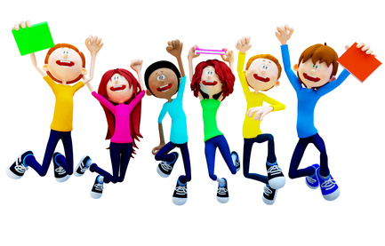
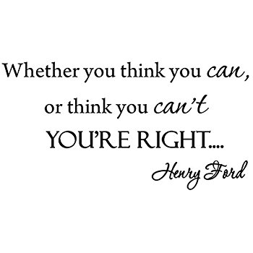
Question 1
Question 1 will give you a source and ask you a question about the topic of the source.
This can be an easy way to get the first 6 marks! Follow this guide:
=
Your own knowledge
+
What the source shows

Have another go:
The trouble had not begun when my storm troopers attacked. Like wolves, they flung themselves in packs of eight or ten upon the enemy. After only five minutes, I hardly saw one of them who was not covered in blood. The hall looked as if a shell had struck it. Many of my supporters were being bandaged, others had to be driven away, but we had remained the masters of the situation.
Adolf Hitler, 1925

Use Source A and your own knowledge to describe the role of the SA (Storm troopers) [6 marks]

Example:
From source A, the role of the SA is shown by the quote ‘I hardly saw one of the m who was not covered in blood’. This shows that the SA were used for violence as they had inflicted injuries upon the people in the hall. It also says ‘many of my supporters were being bandaged…but we had remained the masters of the situation’. This implies that the SA were a part of a brawl in support of Hitler and there was injuries on both sides but the SA had been used successfully the keep the brawl against Hitler under control.

From my own knowledge, I know that the SA was Hitler’s own private army to deal with opposition against Hitler, especially in political meetings. They were violent ex-soldiers that were angry about the past. They had a strong reputation to stop an uprising and where called ‘brownshirts’. As well as this, I know that Ernst Rohm was in charge of this group of men.

Question 2:
Exam Board feedback on the 2019 exams: Most people provided to good general description –BUT most answers lacked enough detail. MAKE SURE YOU USE A LOT OF DETAIL!
These questions ask you to describe an event.
You need to write at least 3 paragraphs describing the main features of an event.
1. Identify
2 Give detailed explanation

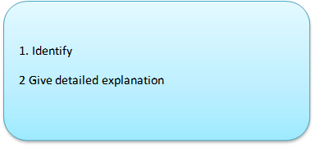
Have another go: Describe why Hitler was invited into power? [8 marks]
1. Identify
2 Give detailed explanation

Explain the situation in the 1932 elections for the Nazi Party.
In 1932, the Nazi party (NSDAP) were gaining votes in the election. In July 1932 the party had 37.4% of the vote which was the most out of all the political parties. In November 1932 their votes had decreased slightly to 33.1% but they still remained the most popular party in the country. This meant that no party could command a majority in the Reichstag. Hitler demanded to be given the post of Chancellor as the Nazi party was the biggest party in the Reichstag.
- Explain the lack of support for Von Papen and Hindenburg in 1932.

Von Papen and Hindenburg were not popular as leaders. By 1932, President Hindenburg was having to use his special emergency powers more and more and so didn’t have to consult the democratically elected Reichstag to make decisions. Therefore by 1932 it could be said that the German democracy of the Weimar constitution had failed. Similarly, Von Papen the previous chancellor resigned as he suggested the Weimar Constitution be abolished and Hindenburg lost all confidence in him.
- State why Hindenburg and Von Papen wanted Hitler to become chancellor of Germany.

Consequently, Von Papen decided to team up with Hitler to create a coalition with Hitler as chancellor and Von Papen as Vice Chancellor, to avoid bringing in Communists into the parliament. Von Papen believed he would be able to control Hitler and told Hindenburg that he would ‘Make Hitler squeak’. On 30th January 1933, Hitler became chancellor of Germany. He was the leader of the largest party and he had been invited to be the chancellor by the president himself and so he was elected to rule. He was able to become chancellor through legal and democratic ways.

Question 3: What is the PURPOSE of a source?
Exam Board feedback on the 2019 exams: TOO LITTLE FOCUS ON THE CONTEXT (ATT) AND THE PURPOSE (WHAT ACTION WAS IT HOPING TO ACHIEVE?)
You need to consider 2 things:
The PURPOSE of the source is ‘why was it created’?
What was it intended to do/ who was it aimed at/ what is it trying to say?
LINK to the CONTEXT – why was it published AT THAT TIME?
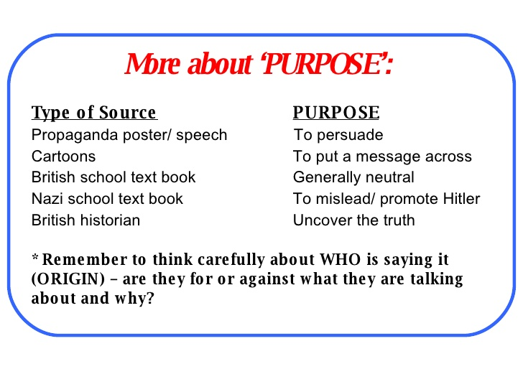
Purpose:
What does it show?
What type of source is it?
Why was it made?
Who made it?

What is the purpose of the source? (what does it want people to do –ATT?)
National Socialist poster, 1932. The poster translates as Work, Freedom and Bread.
Purpose:
What does it show?
What type of source is it?
Why was it made?
Who made it?

I can see from the source that the slogan says ‘Arbeit, freiheit und Brot’ which translates as work, freedom and bread. It also says Vote ‘National Socialists’, this shows that this source is a propaganda poster to try and get votes for the Nazi Party in 1932. It shows a man that looks like a working man looking hopeful and strong.
It was published in 1932, when times were very difficult because it was the time after the Great Depression. America suffered the Wall Street Crash in 1929 and recalled their short term loans from Germany to help her own economy, through the Dawes Plan. Due to this, Germany couldn’t repay the money and so a Depression hit Germany. The depression hit the German people hard and people lost their jobs which meant they couldn’t pay for food including bread. Homelessness was high.
The purpose of the source is that they were using the depression in Germany as a way to get votes from the German people. Bread and work was hard to come by and so they used this to appeal to German workers in particular, note the image used is a German man.
Another purpose is that the Nazi party had started to try and win votes rather than use violence and rise against the government to get into power. Therefore they were releasing propaganda posters to persuade the German people to vote for them, in particular the German people that needed change the most as the Weimar government were doing little, the Nazi party manipulated the situation.

Question 4:
Exam Board feedback on the 2019 exams: Too many people paraphrased (just repeated the source) rather than truly answered the question. You need to focus on CONTEXT and AUTHORSHIP. When was it written and why?
Which of the sources is more useful?
This question asks you to compare the usefulness of 2 sources and make a JUDGEMENT!
All sources are useful. A good way to remember this is to evaluate sources based on their COP. Consider this, but do not write in a COP writing frame as this will definitely limit your ability to truly answer the question.

Content: What information does it have?
Origin: Who created it? When?
Purpose: Why was the source created? What is the aim?

Reasons why B is useful
C
O
P
Reasons why source why A is useful
C
O
P

Overall judgement

Which of the sources is more useful to an historian studying the consequences of the Munich Putsch?
Source B
Although the Nazi Party had failed to take over the government after the Munich Putsch this was not a failure. During Hitler’s trial he became a well known name in months and this even led to his autobiography becoming a best seller. Hitler won over the jury with his amazing ability to speak in front of crowds and gained lots of support. His prison sentence should have been life but he only served 9 months.
V. Gray, British historian ‘’The Munich Putsch’, 2011.
Source A is useful to a historian studying the consequences of the Munich Putsch. From Source A it tells me that ‘the Party is doomed’. This is basically saying that the Nazi Party is going to lose support and respect from the humiliating failed Putsch, which means an uprising against the Weimar government. As well as this, the source says ‘we will all end up prison’. This is useful because it is accurate in the consequences of the Munich putsch because many Nazi officers including Adolf Hitler ended up in prison when they were arrested after the Putsch. Also it is limited in its coverage of the consequences because it only focuses on negative aspects due to the drama of the days after the event.
This source is written in 1923, days after the Munich Putsch and this is useful because it is a primary source that gives us an interesting account from an eye witness, a Nazi Putsch participator and so it gives us his experience of the events. This therefore makes it useful in telling us about the consequences of the Putsch through the eyes of a Nazi member. It also shows us the short term consequences of the Putsch due to its date close to the event.
The source is from a member of the party speaking about the Putsch. This does impact upon the usefulness because it does not say who the Nazi man is talking too, he could be talking to the media and therefore his words could be over exaggerated to entertain the audience and gain views. As well as this, as it is only days after the Putsch it is difficult for the Nazi man to actually know what the after effects of the Putsch would be as the trial had not even started.
Source B is also useful to a historian studying the consequences of the Munich Putsch. From Source B it tells me that ‘he only served 9 months’, talking about Hitler’s prison sentence which he and many other Nazi officers served for treason against the country. This is useful because it is accurate as he did serve this term. I do know though that Hitler served this term in luxurious circumstances with relative freedom and good treatment. The source also tells me that Hitler ‘gained lots of support’ and ‘his autobiography became a big seller’. This is useful because it shows us that there were positive consequences to the Munich Putsch as well as negative aspects such as their prison sentences. Adolf Hitler gained great support by using the media to gain attention and rally support, he used his enthusiasm and defended himself in court in order to look like a martyr for his cause.
The source is written in 2011 by V. Gray and is a book called ‘The Munich Putsch’. The date is useful to a degree because it is by a historian who will have researched the consequences of the Putsch to great detail.
The book is titled ‘Munich Putsch’ and so the title does not offer or suggest great drama and so I would suggest that the audience would be historians, students and those interested in history or the subject. Therefore I would say that the content is not biased and is mainly based on fact. It is therefore useful in gaining factual insight into the Putsch after the events, showing long term consequences.
Overall, both sources are useful in studying the Putsch. Source A offers a primary source eye witness account which shows the feelings of a Nazi member involved in the Putsch although the lack of detail of who they are talking too does limit its use. Source B is very useful because it shows good research and facts and gives long term consequences of the Munich Putsch.

Source A
‘We have failed to take over the Weimar Government!!!! This plan should have worked, we have been betrayed by our own people and outnumbered by the army. This is outrageous, the people need a strong leader. The Nazi Party is doomed. We will end up in prison!’.
Member of the Nazi Party, speaking about the Munich Putsch, 1923 (day after the event).

This question is asking you to write an essay. You should aim to fill the space given and possibly go on to the additional pages.
Exam Board feedback on the 2019 exams: MOST PEOPLE RAN OUT OF TIME TO ANSWER THIS QUESTION WELL. YOU NEED TO GIVE YOURSELF AT LEAST 15 MINS (I WOULD RECOMMEND 20 IF YOU CAN) TO ANSWER THIS QUESTION!!!!!!!! IT CARRIES THE MOST MARKS ON THE PAPER!!
You need to include: Both sides of the argument
A range of factors/different groups that are involved.
You need to make sure you include a good range of information. It might look something like this:
Group 1: Women, unemployed, trade unionists etc
Briefly, how did life change for them under the Nazis?
Did this improve their lives?
Did this worsen their lives?

Group 2:
Briefly, how did life change for them under the Nazis?
Did this improve their lives?
Did this worsen their lives?

Group 3:
Briefly, how did life change for them under the Nazis?
Did this improve their lives?
Did this worsen their lives?

Women’s lives in Germany changed exponentially under the leadership of the Nazi Party. Professional women were forced to abandon their vocations and adopt a domesticated role at home. The Nazi policy of Kinder, Kuche, Kirche encouraged women to play an active role in boosting Germany’s population by rearing large families and raising their children with the ideals of Nazism.
Some women welcomed the way that the Nazi Party sought to change their lives. They embraced their maternal instincts, taking marriage loans from the government and reared large families to receive their Nazi motherhood medals and
For many women, the Nazis changed their lives for the worse. Those who had dedicated their lives to professions in law, medicine and education now found themselves unable to practice in these professions thanks to an Act of Parliament proclaimed in 1935. Moreover, women in Weimar Germany lived relatively liberal lives and many enjoyed wearing make-up modelling themselves on the latest fashions from the USA and smoking. Nazi ideology discouraged women from living such lives and they were now expected to wear modest make up, traditional simplistic clothing and refrain from drinking alcohol and smoking cigarettes.

