UNIT 3:
CRIME & PUNISHMENT

2019 Exam feedback: Support your statements with facts. More CONTEXT needed. ATT (at that time) – eg. why did they do that at that time?
Welsh references in question 7!
This is a thematic study. This means you study only crime and punishment, but over a very long period of time: 1500 – Present Day. There are 7 Key Questions:
- Causes of crime: What have been the main causes of crime over time
- Nature of crime: How has the nature of criminal activity differed and changed over time?
- Enforcing Law and Order: How has the responsibility of enforcing law and order changed over time?
- Methods of combating crime: How effective have methods of combating crime been over time?
- Attitudes to punishment: Why have attitudes to punishment changed over time?
- Methods of punishment: How have methods of punishment changed over time?
- A study of an historic site connected with crime and punishment: China, the growth of crime in Industrial Merthyr in the 19th century (not in this booklet)
CAUSES OF CRIME

GLOSSARY
- Poverty = the state of being extremely poor.
- Rural depopulation = people moving from the countryside to the towns in search of jobs
- Unemployment = not working
- Able-bodied = able to work but don’t. Also known as Sturdy Beggars. Possibly turns to crime to survive.
- Deserving poor = poor because of circumstances outside of their control, e.g. blind, incurable illnesses
- Rogues = a dishonest or unprincipled man.
- Vagabonds = A homeless unemployed person.
- Heresy = Going against the official religion of the country.
- Recant = Saying that you no longer believe in something.
- Puritan = extreme Protestant.
- Treason = plotting against the monarch or government.
- Pillory = A wooden frame used to secure people’s heads or hands.
- Rebellion = an act of armed resistance to a leader.
- Smuggling = Getting goods into a country illegally. Often to avoid paying tax.
- Excise duty = A tax on goods made within a country.
- Customs duty = A tax put on imports.
- Contraband = Smuggled goods.
- Preventative Officers = officially known as the Revenue Men of the Customs and Excise Service. They were people who caught and arrested smugglers.
- Footpads = A highway robber who attacked victims on foot so often robbed pedestrian travellers.
- Highwaymen = Highway robbers who rode on a horse so attacked stage coaches and travellers on horseback. Often used firearms.
- Industrial Revolution = The quick development of industry in the 18th and 19th century.
- Agricultural Revolution = The quick development of agricultural machinery and techniques.
- Industrialisation = The spread of industry.
- Urbanisation = The growth of towns.
- Push factors = Something that makes you want to leave there.
- Pull factors = Something that makes you want to go there.
- Criminal class = people who committed minor thefts.
- IRA = a largely Catholic group who used violence to try and end British rule in Northern Ireland.
What were the main causes and types of crime in Wales and England in the sixteenth and seventeenth centuries?
- The problem of vagrancy
  - (causes: poverty, rural depopulation, unemployment; able-bodied poor and deserving poor; rogues and vagabonds)
- The challenge of heresy
  - (changes in religion and religious opposition; attitudes to heretics)
- Dealing with treason
  - (definition of treason; of the Gunpowder Plot)

The problem of vagrancy
Causes of poverty
- Rising population = By 1550 there was 3.2million people in Wales and England. 50 years later it had risen by nearly 1 million.
- Bad harvests = 1556, 1596 and 1597 were particularly bad. Threat of starvation.
- Rising inflation = wages couldn’t keep pace with rising prices.
- Fighting costly foreign wars = meant the king or queen raised taxes. When wars were over sailors and soldiers returned with no jobs.
- Rack-renting = landlords kept increasing rent. Many were evicted.
able-bodied poor and deserving poor
- Poor were expected to fend for themselves. Unable to find jobs many left their homes and wandered the streets begging for food. Became a serious worry for the government and the respectable people of the towns.
- Prisons were used at this time to punish vagrants. Lots of people were very concerned. In 1557 William Harrison divided the vagrants into 3 types;
  - Deserving poor
  - Poor by misfortune
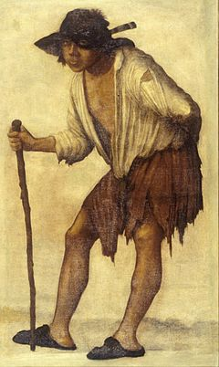
  - Idle and work shy
rogues and vagabonds
- Harman wrote a book where he warned about the dangers posed by vagabonds – he identified 23 different sorts vagabonds, such as counterfeit cranks (sucked soap to foam at the mouth and pretended to have fits) and Abraham man (pretended to be mad).
- These false beggars added to the view that vagabonds caused crimes.
- People felt more and more threatened by the growing numbers of beggars.
- The view was that vagrants were criminals, spread diseases, too lazy to look for jobs.
- During Elizabeth’s reign it became obvious that they would have to do something to help the deserving poor and punish the lazy rogues – Poor Laws of 1598 and 1601 were passed.

The challenge of heresy
changes in religion and religious opposition
- Majority of people in 16th and 17th Centuries were very religious. In 1500 most were Catholic but some were becoming Protestants.
- Henry VIII created the Church of England and left the Catholics when the Pope wouldn’t give him a divorce. When Henry died his son Edward ruled England as Protestant. When Edward died the country became Catholic under Mary. When Mary died the country became Protestant again under Elizabeth. This was all in the space of about 15 years.
- People who went against the official religion were often tortured or executed.
attitudes to heretics
- During their trials heretics were given the opportunity to recant. If they did they would receive a prison sentence. If they didn’t they would be sentenced to death.
- It was believed that heretics had rebelled against God so their bodies had to be destroyed by burning, leaving nothing for the day when God would resurrect Christian believers.
- When Elizabeth became Queen she attempted to create a religious compromise called the middle way. However any Catholics or Puritans who refused to accept this were treated as heretics and punished, especially anyone who tried to spread different religious ideas.
- Some who disagreed with the monarch’s religion went into exile abroad or accepted death. However most just learned to keep quiet.
- Most of the opposition was from individuals except the Pilgrimage of Grace which saw a protest of 30,000 pilgrims against the religious changes Henry VIII was making.
Dealing with treason
Gunpowder Plot of 1605
- Cause; Catholics were annoyed that James I had made the laws against Catholics stricter.
- Aim; Catholics wanted to kill the king during the opening of parliament, taking his daughter and raising her as a Catholic.
- End; Discovered before it could be put into action.
- Historians have two different views – some disagree with the ‘official view’ and think the plotters were framed so that the king had an excuse to persecute Catholics.
  - Official View
    - Plotters intended to blow up the king by lighting 36 barrels of gunpowder which they stored in a rented cellar under the House of Lords.
    - They dug a tunnel under the HoL but they encountered a thick wall so had to abandon that.
    - One of the plotters wrote an anonymous letter to his brother in law (Mounteagle) warning him not to attend parliament.
    - Mounteagle showed it to King James.
    - On 4th November guards searched the cellars and caught Guy Fawkes.
    - He was tortured for 4 days and gave the names of other plotters. They were all found guilty of treason and hung, drawn and quartered.
  - Problems with this...
    - The cellar was rented by a king’s official.
    - No tunnel was ever found.
    - It’s unclear how they could get so much gunpowder when the government controlled the supply of it.
    - Lord Mounteagle showed the letter to the king on 27 Oct but the govt took no action until 4 Nov.
    - The man who wrote the letter was not arrested with the other plotters.
- The plot made the Catholics unpopular and harsher laws were passed against them. They were banned from certain high powered jobs.
- Henry VIII tried to silence opposition by introducing a new set of treason laws which said that;
  - Anyone who said or wrote things against the king or their family was guilty of treason.
  - Anyone who kept silent when questioned on what were the rights and authority of the king was guilty of treason.
- This now meant that political as well as religious opinions could be classed as treason and sentenced to death.
- James I and Charles I believed in the ‘Divine Right of Kings’ and claimed that God had selected them to rule – therefore they could do no wrong as they represented God on earth.
- Very often rebellions were caused by a combination of political and religious factors. Sometimes it was caused by poverty.
 | Wyatt Rebellion | Teenage Apprentice Riots | Popish Plot | Monmouth Rebellion
Year | 1554 | 1595 | 1678 | 1685
Cause | Religion | Economic | Religion | Religion
Events | 4000 protestors marched on London to overthrow Mary and replace her with Elizabeth | Apprentices stole food from a market as they were very poorly paid despite their training. They were whipped and put in the pillory and imprisoned. It was the start of disturbances and riots across London. | Oates claimed he'd discovered a plot to kill Charles II. Led to the spread of anti-Catholic hysteria. However Oates had made it all up. | Monmouth was the illegitimate son of Charles II who believed he should have succeeded him to the throne and led a rebellion.
Outcome | Easily defeated and forced to surrender | Didn't work. | The false accusations led to the arrest and execution of 35 men accused of treason. | Monmouth and his forces were defeated.
Punishment | Wyatt and 90 rebels executed for treason | 5 apprentices involved were executed for treason. | Oates was arrested and sent to prison for perjury. | Monmouth was executed for treason.

How did types of crime and their causes change in Wales and England in the eighteenth and nineteenth centuries?
- Increase in smuggling
  - (reasons for the increase in smuggling; smugglers and excise men; attitudes towards smuggling)
- Highway robbery
  - (issues involving stagecoach travel; lack of law enforcement; highwaymen and footpads)
- The impact of industrialisation
  - (social and economic change; the development of large towns; examples of unrest leading to crime: Luddism, Swing and Rebecca Riots)
Increase in smuggling
Reasons for the increase in smuggling.
- Excise duty – traditionally covered chocolate, beer, tea and spirits but after 1688 it was widened bit by bit to include essentials like salt, leather and soap.
- Custom duty – kept rising. By 1750 the tax on tea was 70% of its original cost.
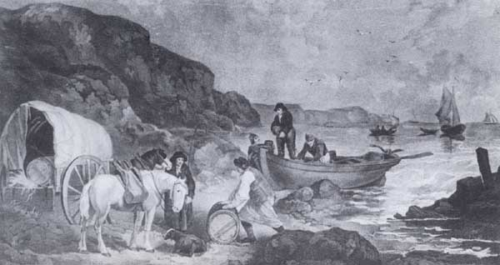
- The fact there was both custom and excise duty annoyed a lot of people.
- Many people didn’t see it as a crime.
- People, such as farm labourers, could earn six times their daily wage in just one night.
- Plenty of investors were willing to put up the money to pay for smuggling of expensive goods like brandy or silk.
- There weren’t enough customs officers to patrol the coastlines so people found it easy to smuggle.
- Once they were smuggled the goods were much cheaper than they would be if they had been imported legally.

There were loads of different people involved in smuggling;
  - Venturer – the person who funded the smuggling operation. They got money once all the goods had been sold.
  - Spotsman – Brought the ship full of smuggled goods to the right place.
  - Lander – Organised how the goods would get from the ship to where they needed to go.
  - Tubmen – Those who did the heavy lifting.
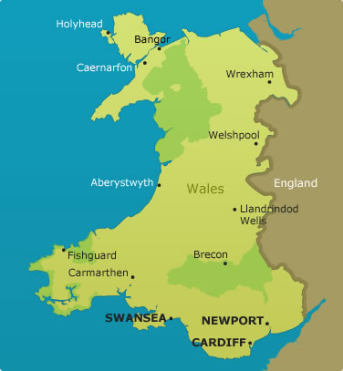
  - Batsmen – Thugs with clubs or guns who would use violence against any customs officials who tried to break up the operation.
Smuggling was more likely in Wales because 3 sides of it are on the coast.
  - Well known Welsh smugglers included;
  - William Owen who smuggled brandy and salt from the Isle of Man to Wales until he was executed.
  - Lucas Family whose family was involved with smuggling for over 200 years.
Smugglers and excise men.
  - The government passed several laws to try and limit smuggling;
  - Hovering Act 1718 – made it illegal for smaller ships to wait within 6 miles of the shore. People would be punished by transportation.
  - Act of Indemnity 1736 – Introduced death penalty for anyone for who injured officers in the line of duty, fined people for bribery and gave a free pardon to a smuggler who revealed the names of other smugglers.
  - However even if smugglers were caught it was difficult to convict them. Because people believed it wasn’t really a crime they didn’t talk to the authorities when questioned. Informers ran the risk of being attacked and judges received death threats.
Decline of Smuggling
  - The government decided that smuggling was caused by the high duties so they cut duties on items such as tea which had a duty of 119% cut to 12.5%. This meant it now wasn’t profitable for smugglers. Therefore smuggling greatly declined.
  - Another reason it declined was because of the Napoleonic War which meant there was a fear of invasion from France so the government built lots of watch towers. This meant it was also easier to spot smugglers.
  - Coast Guards were set up in the 1820s which also meant smuggling declined.

Highway robbery
Issues involving stagecoach travel
  - Because of the development of industry and towns more people moved around places.
  - Better transport links and more traffic brought more opportunities for crime.
  - Highway robbery had happened in the 16th and 17th centuries but became more common in the 18th century.
  - Some roads got a reputation for being particularly unsafe.
  - Factors that made highway robbery more common;
  - Handguns were easier to get and use.
  - There wasn’t an organised police force.
  - People were becoming wealthier and carried more money and jewellery with them.
  - People had to carry cash because there weren’t many banks.
  - The roads outside of towns were quiet so robbers found it easier to hide.
Highwaymen and footpads
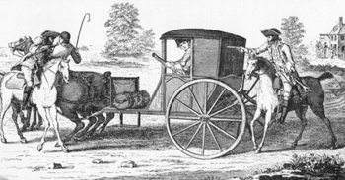
  - Highway Robbery caused great alarm as it involved violence and sometimes ended in murder.
  - There were two types of highway robber – footpads and highwaymen.
  - Most robberies took place on the roads in and out of London.
  - The myth of highwaymen were that they were masked, glamorous and well dressed who rarely used violence. In reality they were violent and cruel.
Richard ‘Dick’ Turpin
  - Best remembered highwayman.
  - Part of a gang of violent house-breakers before turning to highway robbery where he paired up with Tom King.
  - He fled to Yorkshire after becoming ‘wanted’ where he used a false name and set up a business buying and selling horses.
  - In April 1739 he was arrested on suspicion of horse stealing and hanged at York.
Decline of Highway Robbery
  - The last recorded highway robbery took place in 1831 due to;
  - London was growing quickly and the open spaces were being covered with buildings.
  - Banknotes were being introduced which were easier to trace.
  - London was becoming better policed.

The impact of industrialisation - Causes of Crime in the 18th and 19th centuries
  - More use of new methods and machinery on farms led to less demand for agricultural workers. Many therefore leave the countryside to look for work in the towns. Because of this towns grew quickly.
  - This greatly changed the way people lived and worked. The increase in population in the town meant that there was more crime.
Social and economic change
  - Criminals liked to live in places that were full of narrow, twisting, crowded alleys that meant they could slip away quickly if they were chased.
  - There was a sharp increase in crime due to population increase, economic problems caused by the end of the Napoleonic War and bad harvests, poor living and working conditions and political unrest.
  - Crimes such as highway robbery declined but new crimes such as railway crimes (like stealing luggage) increased. Pick pocketing also increased.
The development of large towns
Push | Pull
Due to new farming machinery it was becoming more difficult to get work in the countryside. | Railways being built made transport easier and cheaper.
The wage of an agricultural worker was very low. | Factories, mines and ironworks needed lots of workers.
Because of bad harvests many poor people who lived in the countryside were near starvation. | Factory owners built houses for their workers next to the factories.
The rural population was growing so there were not enough farming jobs to go around. | Industry gave employment throughout the year whereas agriculture was only seasonal.
 | Factories gave employment to the whole family.
  - The quick growth of towns brought both health and social problems.
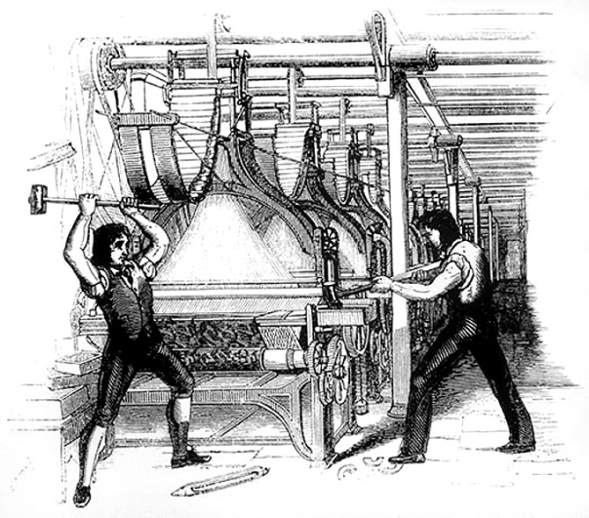
  - To maximise profits the houses had been built as cheaply as possible – there was no street lighting, no piped water, no indoor toilets, drains or sewers.
  - Rubbish was thrown on the streets and disease, illness and early death were common.
Luddites
  - Introduction of new machines meant that workers were losing their jobs. As a last resort these workers ganged together to attack and smash the machines.
  - This happened throughout the country. In one case in Yorkshire the mill owner was murdered.
  - The government responded by sending 12,000 troops and passed a law that make frame-breaking (the machines) punishable by death.
  - In 1813 17 Luddites were executed. Many were fined whilst others were transported.
  - The harsh punishments meant Luddism faded away and the machines remained.
Swing Riots
  - Gangs of protestors attacked the property of the rich farmers. It was mostly done by annoyed farmers who were angry about being in poverty and farmers using machinery.
  - Wages were much lower for agricultural workers than industrial workers because agriculture was seasonal.
  - Before many attacks they sent a threatening letter signed ‘Captain Swing’.
  - The authorities gave harsh punishments to those caught. Several hundred were sent to prison, 481 were transported and 19 were hanged.
Rebecca Riots
  - Between 1839-43 gangs of poor farmers attacked toll-gates on roads across west Wales. They disguised themselves as women so they wouldn’t get caught.
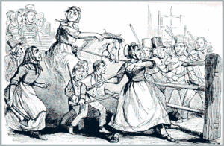
  - The farmers were angry at the high rent and the building of toll-gates which meant you had to pay to travel on a road. The toll-gate keeper could charge what they wanted. They were also angry at having to pay money to the church and the changes in the poor laws.
  - In one attack the toll-gate keeper was killed.
  - Troops were sent into the area and rewards were offered for information about the identity of the rioters. The ring-leaders were either imprisoned or transported.
  - As a result toll-charges were now standardised (the same across the country) and by the mid 1940s there was peace in Wales again.

Why have there been new causes and types of crime in Wales and England in the twentieth and twenty first centuries?
- The rise of transport crime
  - (development of the motor car; creation of new crimes such as: car theft, drink driving, traffic offences)
- The rise of computer crime
  - (computer fraud; stealing from bank accounts; hacking; viruses; identity theft)
- The trend towards violent crime
  - (IRA bombings; football hooliganism; global terrorism; drugs crime; gun and knife crime)
The rise of transport crime
development of the motor car
- Many of the modern crimes are just new ways of committing old crimes, e.g. Stealing a car for joyriding is not that different from stealing a horse. Car-jacking is a modern version of highway robbery.
- Cars first appeared on British roads in 1894. The red flag acts in the late 1800s set speed limits and safety procedures. In 1865 it was a maximum of 4mph in the country and 2mph in towns. Each car had to have a person carrying a red flag walking 60yards in front of it. In 1896 this was changed to 14mph and no need for a person.
- At first only the rich upper classes could buy a car but by the 1930s there were thousands of cars on the road.
- Due to the increase of cars more specific laws had to be introduced. Due to fatal accidents more safety measures were introduced with tests for new drivers etc.
creation of new crimes
- ‘Motoring offences’ has grown into one of the biggest categories of crime. Crimes range from drunk driving to speeding and involve a huge amount of police and court time.
 | Description | When it became common
Theft of vehicles | Stealing a car either by stealing the key or hot wiring. Now houses are burgled to steal car keys. | In 1996 over half a million cars were stolen in the U.K. Now car makers use better security measures.
Theft from vehicles | Breaking in and stealing valuables or robbing them whilst waiting at traffic lights. | During late 1980s theft of mobiles from cars became common.
Car-jacking | Forcing the driver out of the car by force and driving off with it. | 1990s due to better vehicle security so people needed the keys.
Joyriding | Driving a car without the owner’s consent. Commonly associated with young males. | 1990s. In 2012 an 11yr old boy became Britain's youngest joyrider.
- Motoring Offences

  - Driving under the influence of drink or drugs
  - Refusing a roadside breath test
  - Not wearing a seatbelt
  - Using a hand held phone whilst driving
  - No insurance
  - No licence
  - No MOT
  - No vehicle tax
  - Failing to stop after an accident
  - Failing to report an accident
  - Dangerous and careless driving
  - Parking violations
  - Road rage
  - Speeding
  - Car theft

The rise of computer crime
Types of computer crime

- Illegally downloading music or films
- Using the computer to attack the government
- Pretending to be someone else
- Stealing money from bank accounts
- Stealing credit card numbers
- Using speech or writing to intend to harm or intimidate
- Peadophilia
- Child grooming
- Sending bulk email for commercial purposes
- Hacking
- Deliberately spreading computer virus'
- Using it to harass others

development of computer crime
- Many of the computer crimes are just new ways of committing old crimes, e.g. Fraud is still fraud, just a different way of doing it. Identity fraud existed with Dick Turpin and is now done via computers.
- Due to the increase of computer crime more specific laws had to be introduced. The police also have to use more specific technology to catch criminals using computers.
The trend towards violent crime
Reasons for the growth in terrorist activities
- Terrorist groups are willing to work together so they can co-ordinate attacks.
- Terrorist groups believe they can only get what they want through acts of violence.
- Violent attacks result in media coverage and make the terrorist group more famous.
- It’s a form of direct action that show the group can hurt their ‘enemies’.
- Puts pressure on the government or organisation and they do sometimes give in.
- Advances in technology have made the world more vulnerable to terrorist attacks.
- Often they have such strong beliefs that they become fanatical.
- There has been a growth in religious fundamentalism, particularly amongst Islamist groups.
IRA bombings
- Most serious threats of the 20th century came from the IRA (Irish Republican Army).
- They opposed the Protestants in N.I and their violence resulted in Protestant terrorist groups being created like the Ulster Defence Association.
- Between 1969 and 2001 3500 people were killed as the Protestant and Catholic groups both launched attacks against each other.
- The IRA also attacked the British mainland and assassinated politicians or exploded bombs in shopping centres, railways or pubs.
- The violence ended in N.I. in 1998 when The Good Friday Agreement was signed. However breakaway groups like the continuity IRA have continued to carry out violent attacks.
global terrorism in the UK
- One of the most serious international terrorist actions within the UK was the Lockerbie bombing on 21st December 1988. A flight going between London to New York which had just taken off exploded whilst over Lockerbie in Scotland. It killed all 243 passengers and 16 crew members and 11 people on the ground. It’s believed it was the work of two Libyan terrorists. One was jailed in 2009.
- 7/7 attacks on London were suicide attacks that targeted public transport at rush hour in 2005. 4 Islamist terrorists attacked and killed 52 civilians.
- 30th June 2007 a jeep loaded with gas canisters was driven into the glass doors of Glasgow airport and set alight injuring 5 people.
- May 2013 two Islamist extremists brutally attacked & killed Lee Rigby, an off-duty soldier, outside Woolwich Barracks.
- Since 1975 the threat posed by international terrorism has grown dramatically.
- Terrorist attacks around the world include;
    - 9/11 in 2001 which killed over 3000 people.
    - 2002 bombings in Bali which killed 202 people.
    - 4 day siege at a shopping centre in Nairobi.
football hooliganism
- It’s not a new threat – games were abandoned in the early 1900s due to violent actions of football fans.
- During the 1960s it became a much bigger problem – gangs of rival supporters, often under the influence of alcohol, fought each other or attacked property such as cars, pubs or shops.
- Many of these gangs were run by middle class men aged 18-25.
- The bad publicity that the violence attracted caused the authorities to bring in a range of measures in the 1990s to tackle football hooliganism;
  - In 1998 a Special Police Unit was set up to deal with football crime and in 2005 this became the UK Football Policing Unit.
  - The police developed tactics to keep rival groups of supporters apart – fans were escorted to and from matches.
  - Increased use of CCTV and police on horses.
  - In 2000 banning orders were introduced for well known hooligans and racists.
drugs crime
- Not a new crime but has become more well known since the 1950s.
- The ban on drugs like cocaine has resulted in more smuggling happening.
- Gangs use planes, boats, trucks and people to smuggle illegal drugs into the UK. Drugs in small packages are sometimes swallowed by ‘mules’ and then collected after they’ve passed through the body.
- In Wales ‘Operation Julie’ in March 1977 resulted in the arrest of a chemist and his partner who had been producing LSD worth £100 million at their house in Ceredigion and at a mansion in Powys.
- Drug gangs operate their own ‘turf’ and will use violence to protect their turf from rival gangs. This has resulted in more gun crime.
- Drug addiction has led to more of certain crimes like burglary, mugging and robbery. Addicts need a constant supply of money to feed their drug habit and will often turn to crime to get this as it’s difficult to have a full time job when you’re addicted to drugs. Therefore valuable objects that can be easily sold are often stolen.
gun and knife crime
- Often linked to juvenile gangs. The rise in gang culture gives young people a sense of belonging. Gang members often carry knives or guns for protection.
- 2000-2010 saw a large increase in gun crime and this has been put down to extreme gang violence.
- Reasons for the increase in juvenile gang culture are;
  - Poverty
  - Lack of opportunity
  - ‘Must have now’ culture
  - The ever growing divide between rich and poor
  - Breakdown of family values and discipline.
ENFORCING LAW AND ORDER
GLOSSARY
- JP = Justices of the Peace. The most important of the officials. They were unpaid officers. Normally the richer landowners who already had respect. They tried criminal cases.
- Hundreds = large areas of land were split into ‘hundreds’ for organisational purposes.
- Preventative policing = attempting to stop crime from being committed rather than dealing with the consequences of crime.
- Opposed = disagreeing with something.

How were law and order enforced in Wales and England in the sixteenth and seventeenth centuries?
- The role of Tudor JPs
  - (importance of JPs; extent of their work; effectiveness)
- The role of constables and watchmen
  - (parish constables and the extent of their work; watchmen: their work and their effectiveness)

The role of Tudor JPs
importance of JPs
- The 1361 Justices of the Peace Act appointed 3 or 4 JPs per county. They had the power to fine or arrest people.
- They were responsible for enforcing the peace but did have to do this alongside their normal jobs.
extent of their work
- Although they were only supposed to be part-time, by the end of Elizabeth’s reign, JPs were responsible for enforcing over 309 different laws.
- The role of the JP was split into 4 different areas of responsibility;
    - Maintaining law and order
      - They acted as judges on minor cases like petty theft, drunkenness and fighting. For more serious cases such as murder or witchcraft they would meet with all of the other JPs of the county as the Quarter Sessions. In 1554 they were given the right to lock up suspects for 3 days whilst the case was being investigated and then chose whether to put them on trial. They could give a range of punishments such as fines or time in the stocks or pillory. By the middle of the 17th century a judge and jury dealt with all cases that could receive the death penalty as a punishment.
    - Administering local government
      - They were expected to license and regulate pubs, organise road-mending and bridge repair and make sure that genuine vagrants had a license to beg. They also had to keep a register of all people entitled to receive poor relief and then tax the community to raise money to care for them.
    - Carry out the orders of the Privy Council
      - They had to make sure that all of the acts passed by the Privy Council were obeyed.
    - Supervise the work of other law enforcement officers.
      - JPs could rely on Constables. By the 17th Century JPs had to appoint a Constable in every parish. They were also in charge of Watchmen and the Sheriff.
Effectiveness
- JPs played an essential role in keeping law and order in their area and making sure that laws were enforced.
- However during the Tudor period the workload of JPs increased rapidly.
- The system worked well in maintaining law and order. They were only appointed for a year at a time and the monarch had to reappoint them. If they weren’t reappointed it would be a big blow to their reputation and social standing as it would look like they weren’t good enough. This caused many to make sure they performed the job to the best of their ability.
- However this did not stop some of them from abusing their position and gaining financially through their role.

The role of constables and watchmen
parish constables and the extent of their work
- They were chosen by the JPs.
Tudor Constable
- They were chosen by the JPs
and were their assistant.
- Usually chosen from the tradesmen or farmers of the area.
- They were unpaid assistants. This made it an unpopular duty.
- They did not have a uniform or weapons.
- Every able-bodied person was expected to do this. If they refused they could be fined or placed in the stocks. Richer people often paid others to take their turn.
- Tasks included;
  - Making arrests.
  - Watching out for Vagabonds.
  - Catch petty thieves.
  - Inflict punishments like whipping vagabonds.
  - Ensure that taxes were paid.
- They could call on any townspeople to help them and people were duty bound to help.
- The High Constables were appointed for between 3 and 10 years and were often wealthy. Anyone who refused to serve faced a large fine. High constables were in charge of the hundreds.

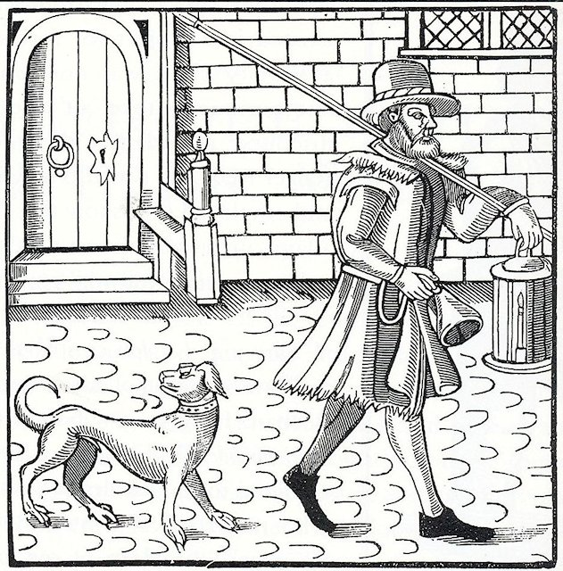
Justices of the Peace
High Constables
Parish constables
Night watchman or Bellman
Charlies
Appointed by the Quarter Sessions (JPs) for between 3 and 10 years
Appointed by the monarch for a year
Appointed by the JP for a year
The town equivalent of the Parish constable
Started in 1663.

watchmen: their work and their effectiveness
- Patrolled the streets at night. Had the power to arrest.
- Expected to walk the streets at night calling out the hours (like a talking clock).
- They didn’t wear a uniform but did dress in thick, heavy clothing to keep warm.
- They carried a bell, lantern and a staff (stick). Sometimes carried a halberd (axe blade and spike on top of a stick)
- Charlies; Started in 1663. Were basically paid watchmen (although only a small amount). Only those who couldn’t get another job were likely to do it. Within 50years they were often mocked as they had little real use. It was often joked that they hid in their sentry boxes at the first sign of trouble.

What were the main turning points in policing methods in Wales and England in the late eighteenth and the nineteenth centuries?
- The Bow Street Runners
  - (the Fielding brothers; establishment of the Runners; importance of the Runners)
- The establishment of the Metropolitan Police
  - (Robert Peel and the 1829 Metropolitan Police Act: reasons and effectiveness)
- Extension of police forces and early police specialisation
  - (The acts of 1835, 1839 and 1856; CID, photography and finger printing)
The Bow Street Runners
- In 1750 Henry and John Fielding began an experiment using paid officials to patrol the streets of London around Bow Street. It was successful. This idea was later used by Sir Robert Peel to set up the Metropolitan Police in 1829.
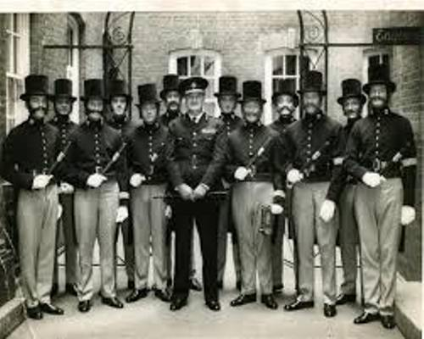
- The newspapers helped bring crime and criminals to the attention of the public. As a result ‘thief-takers’ started to appear. Thief Takers were men who hunted down criminals for rewards. A bit like bounty hunters. The reward was paid by the person who had been robbed.
- If you were robbed you really had to catch the criminal yourself. You could summon a magistrate or post a reward for anyone who could catch the criminal.
- Henry and John Fielding were horrified at the amount of crime being committed in London and were determined to do something to try and stop it.
- Henry looked at some of the causes of the crime which included;
  - Too many people moving to London.
  - People choosing crime rather than hard work.
  - Constables in London were mostly useless.
- Henry set up a force of 6 law officers to work as thief-takers and paid them weekly. They became known as the Bow Street Runners and were well trained.
- At the start they didn’t wear uniforms so that they could blend in on the streets.
- For the first time the criminal gangs found themselves up against a real police force which although small was well-organised.
- Henry Fielding died and his brother John took over. The Fielding brothers put a large emphasis on the public helping them. They started a weekly newspaper called The Public Hue and Cry.
- In 1761 John Fielding was knighted. He died 19 years later.
- Through hard work, experimentation and persistence he had shown Londoners how to deal with crime and how to create a paid police force to protect lives and property.

Legacy of the Bow Street Runners
- The work of the Fielding brothers was continued after their deaths;
  - In 1792 the government passed the Middlesex Justices Act which divided London into 7 police districts with 6 full time constables in each.
  - In 1798 the Thames River Police was set up to prevent thefts from ships and the docks.
  - By 1800 there were 68 Bow Street Runners.
  - In 1805 a Horse Patrol of 54 officers with swords, pistols and truncheons was set up to patrol the highways in and out of London. They became known as ‘Robin Redbreasts’ because of their red waistcoats.
  - By 1829 London had 450 constables and 4000 watchmen.
- The Fielding brothers had introduced the ideas of ‘preventative policing’. The Bow Street Runners and Thames River Police were a deterrent by just being there.
- This is a HUGE turning point in the way that crime and punishment was enforced. Before this point the threat of harsh punishments aimed to deter people. Now seeing a law official was meant to act as the deterrent.

The establishment of the Metropolitan Police
Metropolitan Police
- Lots of people were against the idea of a proper police force because;
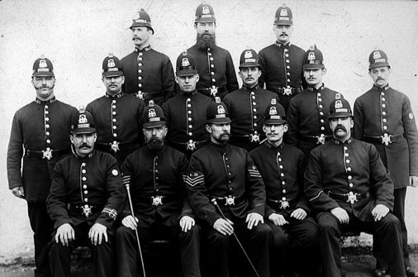
  - It wasn’t the government’s business – people should do preventative policing for themselves.
  - A police force would be an invasion of privacy.
  - Could be used by the government to limit freedom or act as government spies.
  - Would be expensive and cause taxes to rise.
  - People thought it just wouldn’t work.
- However the increase in crime on London’s streets and the growth in population helped convince MPs that change was needed. The man who brought about this change was Sir Robert Peel.

Metropolitan Police Act 1829
- In 1822 Sir Robert Peel became Home Secretary who was responsible for law and order. He though the police force was not good enough.
- He put pressure on the Prime Minister (the Duke of Wellington) to introduce reform. This became the Metropolitan Police Act of 1829.
- Sir Robert Peel was in overall charge but it was run by Charles Rowan and Richard Mayne.
- Its headquarters was at Scotland Yard in London. London was split into 17 divisions, each with 154 constables and 1 superintendent.
- Within a year over 3300 men had joined. The new policemen had to be less than 35, at least 5 feet 7 inches, healthy and able to read and write.
- Constables got paid one guinea a week. Many were ex-soldiers who were later sacked for drunkenness or resigned due to the long hours or low pay.
- They worked 7 days a week and patrolled a set area (which meant walking over 20 miles a day).
- They were made to look different because there was a fear they would act like the army. Therefore they were made to wear a blue uniform so it wouldn’t look like the military one which was red.
- Constables didn’t have a sword but had a wooden truncheon and a rattle to get attention. In 1884 the whistle replaced the rattle.

Metropolitan Police Act 1839
- This was a further act that doubled the area covered by the police. This was the end of the Bow Street Runners and was now replaced officially by the Metropolitan Police.
- Between 1850 and 1900 the Metropolitan Police force increased significantly;
  - 1862; 7800 men.
  - 1882; 11700 men.
  - 1888; 14200 men.
  - 1900; 16000 men.

The spreading of the Met Police into other areas;
- Municipal Corporations Act, 1835
  - Allowed ‘rotten boroughs’ to set up a police force if they wanted to. Only 93 out of 171 had by 1837.
- Rural Police Act, 1839
  - Also known as the County Police Act. Allowed JPs to set up police forces in their counties. Wasn’t compulsory and less than half did.
- County and Borough Police Act, 1856
  - Made it compulsory for a police force to be in every county. There were inspectors of Constabulary which checked if they were good enough.
The public reaction to the new police force
- Criminals hated them and even honest citizens mocked them. When the police tried to control traffic the noblemen would order their coachmen to run them over. Newspapers also complained about them.
- Before 1829 the magistrates had control over the constables but they lost this control when the metropolitan police was formed. The magistrates were really annoyed and jealous and obstructed the constables in every way they could.
Detective Branch, 1842
- One of the first cases was The Bermondsey Horror of 1849 in which a married couple murdered Patrick O’Connor and buried his body under the kitchen floor. After going on the run they were tracked down by the detectives and publicly hanged after being found guilty. Through cases like these the suspicion people had was replaced by respect and crime steadily fell.
- Criminal Records Office 1869
  - Contained the records of criminals from all over the country.
- CID (Criminal Investigation Department) 1878
  - Replaced the detective branch. They were paid slightly more than uniformed officers.
- Special Irish Branch 1883
  - Created due to the threat of Irish terrorism. In 1888 became simply ‘Special Branch’.
- Photography and fingerprinting
  - Photographing of prisoners started in 1850s and meant that images could now be sent around the country. Fingerprinting started in 1901. Within the first 12 months they identified 4 times as many criminals as had done the year before.

How have policing methods developed in Wales and England in the twentieth and twenty first centuries?
- Increased resources for the police
  - (transport developments; communication and increasing use of technology; training and recruitment changes, including women police)
- Specialisation of police services
  - (development of specialist branches; development of CID, forensics, community relations, crime prevention)
- Modern day problems for the police
  - (police use of weapons; increased powers of arrest and of questioning; pressures of red tape and more organised criminals)
Increased resources for the police
Transport developments
- One of the biggest changes resulted from new methods of transport.
- Bicycles were first introduced for police officers in 1909 and the car was used by police from 1919. This meant that police could get to the scenes of crimes much quicker.
- By 1970 the patrol car had become an essential tool in policing, replacing the ‘bobby on the beat’ with rapid response cars.
- However due to public pressure the police forces re-introduced foot patrols in the late 1900s to reassure locals that police officers were on hand.
- Since the 1970s the police have used helicopters to help with the surveillance of criminal, to track stolen vehicles and to direct police on the ground in the search for missing persons.

Communication and increasing use of technology
- Telegraph and radio
  - By 1880 most London police stations were linked by telegraph.
  - Police phone boxes appeared in the 1920s.
  - In 1934 some police cars were fitted with two-way radios, but the reception was often poor.
  - In 1937 the 999 emergency number was introduced.
  - In 1963 all police officers carry a two way radio for instant communication.
- Camera and video technology
  - In 1901 the first police photographer was employed.
  - Many police cars have cameras fitted including automatic number plate recognition systems.
  - CCTV has helped solve many crimes.
  - Camera technology is also built into police helicopters and uses night vision.
- Computer technology
  - Computers have greatly improved police record keeping. They save a huge amount of police time.
  - The system holds information on fingerprints, DNA, missing persons, car details etc. It can alert police to criminals who have committed crimes similar to the one being investigated and can monitor websites and emails which plays a major role in anti-terrorist activities.

Training and recruitment changes, including women police
- A National Police Training College was set up in 1947 and provided all constables with at least 14 weeks of basic training.
- In order to recruit high quality candidates into the profession all applicants have to go through a common application process and have to complete the following;
  - Entry requirements, e.g. Exam qualifications
  - Police Initial Recruitment Test which includes an interview and tests.
  - Police fitness test
  - Health check
  - Background and security checks.
- Women;
  - In 1919 the first women police officers appeared. They weren’t allowed to carry handcuffs or make arrests until 1923.
  - Until 1939 they were given only limited duties, such as patrol work, escort duty (looking after children and female prisoners) and hospital duty.
  - Since WW2 the number of female officers have increased. However it wasn’t until 1970 that they were fully integrated into the police service.
  - They now have similar duties to male officers but they are much fewer in number.
Specialisation of police services
- Developments in science has resulted in the growth of specialist branches, such as;
  - CID (Criminal Investigation Department) – has plain clothes officers and investigates major crimes like murder, serious assaults, fraud and sexual offences.
  - Counter terrorism branch
  - Immigration
- Scientific developments include;
  - Fingerprinting
  - Forensic scientists, Scenes of Crimes Officers (SOCOs) and Crime Scene Investigators (CSIs)
  - Genetic fingerprinting aka DNA profiling which matches individuals by blood, skin, saliva or hair found at a crime scene.
Community policing
- Since criticism of the police handling of serious civil disturbances, such as the Brixton Riots in London in 1981, attempts have been made to improve relations between the police and the communities they serve;
  - Community Relations Branch (1968): attempted to build closer ties with immigrant communities but it had limited success.
  - Neighbourhood Watch Schemes (1982): Over 10 million members of it across the country. The police pass on information about local crime trends to the co-ordinators who also act as the link to inform the police of incidents when they happen.
  - PCSOs (Police Community Support Officers) 2002: Civilian members of the police who are not as trained, have a modified uniform and carry less equipment. Main role is to be a presence in the community and gather criminal intelligence.
  - Crime Prevention Schemes: Police give advice on issues such as personal safety and home security.
  - Victim Support Schemes: Helps victims of crime through advice, counselling and reassurance.
Modern day problems for the police
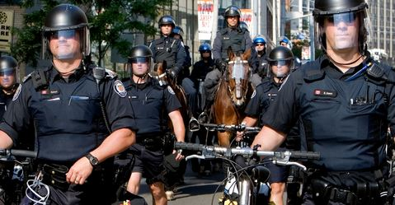
- Use of weapons
  - Officers now wear a stab vest as part of their uniform. They carry a baton, radio, notebook, handcuffs, CS spray, small first aid kit and a torch. Some will also carry tasers. Armed response officers and SO19 also carry firearms.
- Increase in police powers
  - Police and Criminal Evidence Act 1984 (later the Police Act 1996) set out the powers of the police. Police can detain people, stop and search people or vehicles and arrest people.
  - Some argue that it’s given the police too much power.
  - The Terrorism Act 2000 allows the police to arrest and detain a person for 48 hours without charge if they’re suspected of being a terrorist. A judge can extend this to 7 days.
  - The police have the power to stop and question someone if they think they have either committed an offence or witnessed something. That individual will be expected to provide the police with their name and address and if they refuse they could be charged. A person can be held for up to 24 hours before being released or charged.
- Pressures of red tape
  - Officers are expected to keep written records of all of their dealings with the public. Critics argue this time would be better spent catching criminals.
  - Individuals are more aware of their rights and an increase in ‘blame culture’ where police are often sued for failing to follow the correct procedure.
  - More crime is happening across different countries – Interpol (International Criminal Police Organisation) organises co-operation between police forces in 190 different countries.

PUNISHMENTS
GLOSSARY
- Corporal punishment = punishment of the body
- Deterrence = making people afraid to commit a similar crime
- Retribution = making criminals suffer for the wrong that had been done
- Monarch = king or queen.
- Hulks = disused ships used as emergency prison accommodation to hold prisoners awaiting transportation. Used due to lack of space in prison.
- Criminal Code = laws and punishments in Wales and England between late 1600s and early 1800s. Aka the Bloody Code due to its excessive use of the death penalty.
- Abolished = got rid of / ended.
- Jail fever = typhus, a disease caught in prison.

How were criminals punished in Wales and England in the sixteenth and seventeenth centuries?

- The use of corporal punishment
  - (purpose of this punishment; whipping/flogging; stocks and pillory)
- The use of public executions
  - (the need for punishment in public; the Marian persecution; treatment of individuals such as Mary, Queen of Scots and John Penry)
- The use of imprisonment
  - (use of houses of correction; Bridewells; debtors' prisons)
The use of corporal punishment
purpose of this punishment
- Punishments had two aims; Deterrence and Retribution. The punishments were meant to fit the crime, e.g. Burning for arson, hanging for murder.
- Corporal punishment usually took place on a market day in an open area so that it was as public as possible.
- The type of punishment someone got was based not only on their crime but also on their status e.g. The higher classes got less harsh punishments.
whipping/flogging
- Used for crimes such as begging, drunkards, those who misbehaved in church, petty theft, vagabonds etc.
- Became less common by the 18th century. Eventually abolished as a punishment for women in 1820 but continued for men until the 1830s. Could still be used as a punishment for offences in prison up to the early 1900s.

stocks and pillory
- The main purpose was to humiliate offenders in public to deter others.
- Used to punish minor crimes, gamblers, beggars and political offenders.
- In pillory’s criminals could be pelted with stones and rotten fruit. If convicted of sexual crimes they were likely to be attacked whilst in the pillory and in some cases were killed.
- If the criminal was convicted of not paying taxes they were often cheered by the onlookers.
- Abolished in 1872.

The use of public executions
the need for punishment in public
- By the end of the 17th century 50 different crimes carried the death penalty.
- Was done in public to deter others.
- Law and order was based on fear.
- Needed to be quick and cheap as there weren’t many ways of detaining people.
the Marian persecution
- It was believed that everyone should follow the same religion which should be chosen by the monarch.
- Henry VIII broke away from the Catholic Church and created the Church of England. When he died his son Edward decided to rule the country as Protestant. His half sister Mary then declared the country Catholic when she ruled it. People who refused to change religion were persecuted and burned at the stake.
- Under Mary I protestants either fled England or were forced to turn Catholic. Those who refused risked being executed. Hundreds were. It was believed that burning the body would free the soul to travel to heaven. Mary hoped this would deter people from being protestant but in reality it just turned people against her.
- Mary I died in 1558 and was replaced by Elizabeth I who turned the country Protestant. This meant that now Catholics were persecuted.
treatment of individuals such as Mary, Queen of Scots and John Penry
- Mary Queen of Scots
  - Elizabeth I’s cousin who was Catholic and often suspected of being involved in plots to kill Elizabeth and take her place on the throne. Very limited evidence of this but letters were discovered and Elizabeth was then put on trial and found guilty of treason. She was finally executed in 1587.
- John Penry
  - Welsh puritan (extreme protestant) who opposed Elizabeth I. Found guilty and sentenced to death.
- John Stubbs
  - Published a leaflet criticising Elizabeth. Punished by mutilation and had his hand cut off in public using a meat cleaver and mallet.
The use of imprisonment
houses of correction
- King Edward VI gave the royal palace of Bridewell to the city of London to house homeless children and punish disorderly women.
- This introduced the idea of reforming criminals rather than just the aim of deterrence or retribution.
- Houses of correction housed the poor, the sick and the sturdy beggars. The idea was to turn people into useful citizens by setting them tasks to do. Under Edward’s reign it was used for correction.
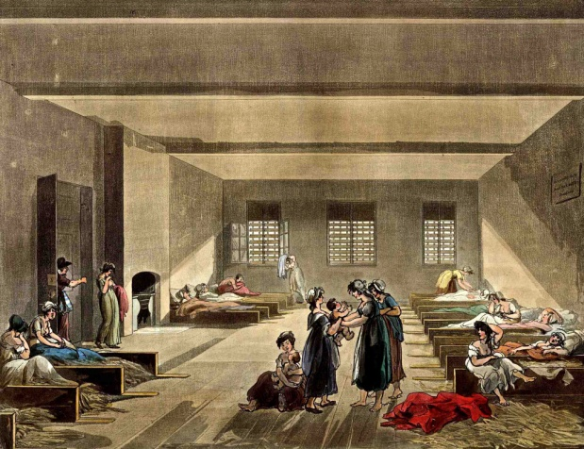
- When Mary took over from Edward she turned it into a place for punishment. Vagrants would be locked up. When Elizabeth took over it was mainly used for religious and foreign opponents.
Bridewells
- Ipswich and Norwich were the first towns to follow London’s example. Houses of Correction became known as Bridewells as this was where the first one was.
- Anyone who refused to work in the Bridewell was whipped.
- Many Bridewells were built throughout the country. They were mainly used to punish vagrants who were firstly whipped and then chained up.
Prisons
- Sending someone to prison at this time was not seen as a punishment but just somewhere to keep them until punishment was decided so they didn’t run away or disappear before they were charged and punished.
- If a prisoner refused to plead either way they would be tortured by being tied down and having heavy weights placed on their chests until they pleaded or died. This was later used as a form of execution rather than torture.
- Conditions in prisons depended on how much you could pay for your food and for bribes. The more you could pay the better bed and food they would get. Conditions were appalling for the poorest.
- Jailers (the people guarding the prisoners) often did not get paid so depended on getting money from the prisoners.

What were the main turning points in methods of punishment in Wales and England in the eighteenth and nineteenth centuries?

- The development of transportation
  - (reasons for transportation; the hulks; destinations; the voyage to Australia and the punishment there)
- Changes in public execution
  - (the reform of the Criminal Code, 1823; problems with public execution; the end of public execution)
- The need for prison reform
  - (the work of John Howard, G O Paul and Elizabeth Fry; the separate and silent systems)

The development of transportation
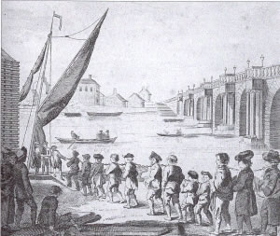
Reasons for transportation
- 1717 Transportation Act was passed. It was a major turning point. It allowed convicts to choose transportation to America instead of branding, whipping or sometimes hanging.
- The sentence was for 7 years, 14 years or life.
- Between 1718 and 1776 more than 30,000 British prisoners were transported to America. People would make lots of money by transporting convicts to America as they would sell them when they got there.
- Transport to America stopped in 1776 when America declared its independence from Britain. This caused a crisis in the British prison system as prisons couldn’t cope with the resulting overcrowding. Overcrowding ended when Australia was chosen as an alternative colony for shipping the convicts to.
- Why were convicts transported to Australia?
  - Would reduce crime in Britain by removing the criminals.
  - An alternative to hanging which some people felt was too extreme for some crimes.
  - Prison was too costly.
  - Hard work and learning new skills would reform the criminals.
  - Australia was newly discovered and the terror of the journey was a punishment in itself.
The hulks
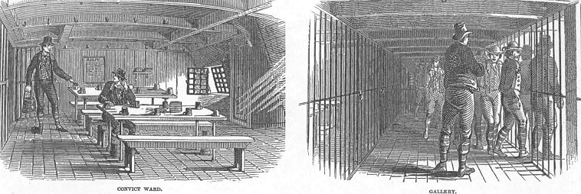
- Between 1776 and 1778 more than a quarter of prisoners died on the hulks due to the horrible conditions.
- There was also lack of supervision so there was lots of disorder, fighting and rioting.
- Because of this the government were concerned and a public enquiry ordered conditions to be improved considerably.
- On board the day started at 5.30am with breakfast at 6am. Food was the same as in normal prisons. Convicts left the hulk for work at 7am doing various physical tasks such as clearing rubbish and carrying coal.
The voyage to Australia
- In May 1787 736 convicts were transported from Portsmouth to Australia. The journey lasted more than 8 months. More than 40 died on the journey from storms, diseases or starvation.
The punishment in Australia
- Convicts were assigned work for private individuals. The convicts were made to do whatever work their master chose to give them;
  - Farm workers often found themselves at a remote and isolated farm.
  - Domestic works were usually well treated.
  - Skilled workers were put to good use.
- Good behaviour could lead to rewards;
  - Ticket of Leave – allowed them to move and work wherever in Australia they chose.
  - Conditional Pardon – set free but not allowed to return to England.
  - Absolute Pardon – Sentence was cleared and they were allowed to return home.
  - Certificate of Freedom – introduced in 1810 and given to convicts at the end of their sentence.
- If they convicted a further crime whilst in Australia they would be sent to a penal settlement were it was hard physical labour and low amounts of food.
- In 1838 it was decided that it wasn’t enough of a deterrent and that it was very expensive. Australia were also very annoyed at being used as a human dumping ground.
- The last convict ship left Britain in 1867.
- Between 1787 and 1867 about 162,000 convicts were sent to Australia. The total cost had been more than £8 million.
Changes in public execution
The reform of the Criminal Code, 1823
- In 1688 there were 50 capital crimes (crimes carrying the death penalty). By 1765 there were 160 and by 1815 there were 225.
- The big change in the death penalty was the amount of minor crimes punished by it in the 18th and 19th century.
- Despite the huge numbers of crimes punishable by death the criminal code wasn’t working and people were beginning to think the death penalty was too harsh.
- Even though the crime rate was rising less people were being executed as juries thought it was too harsh so were reluctant to find people guilty.
- With juries being unwilling to convict people some criminals could feel confident of escaping punishment and were more likely to commit crime. Ideas about punishment had to change.
- People started to believe that with the correct punishment criminals could be reformed.
- Politicians began to look for different punishments that would be more effective in deterring people.
- Sir Samuel Romilly was a major campaigner against the Criminal Code and was determined to reduce the number of crimes punishable by death.
- In 1808 the death penalty was abolished for pick pocketing.
- When Sir Robert Peel became Home Secretary abolished the death penalty for more than 100 capital offences.
- By 1861 only 5 crimes were punished by death (murder, treason, espionage, arson in royal dockyards, piracy with violence). The criminal code was finally abolished.
Problems with public execution
- Tyburn (village outside of London) was a popular place with a gallows where several people could be hanged at the same time. It was meant to act as a very obvious deterrent. Executions were a main feature of public entertainment.
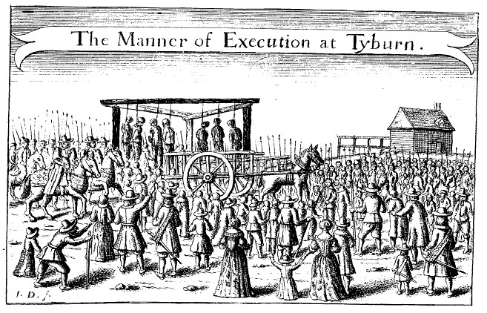
- A major problem with hanging was the possibility of a miscarriage of justice. Dic Penderyn was hanged and then later someone else confessed to the crime.
- One of the last executions in public took place in Nov 1864. By the 1860s the authorities thought the problems with public executions were too great, as they were often events at which there was a lot of petty crime, and the system had to change.
The end of public execution
- In 1866 the Royal Commission on Capital Punishment recommended that executions should no longer happen in public. In 1868 this was made official.
- From 1868 to 1965 when capital punishment was abolished, executions were carried out in prison.
The need for prison reform
- John Howard
  - He was shocked by the conditions he saw in prisons. He believed prisons should reform criminals and believed that prisoners should be kept in solitary confinement so they couldn’t learn more from other criminals. He died after catching jail fever.
- Sir G. O. Paul
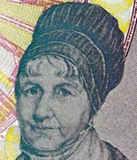
  - Concerned about the conditions in prisons. The Gloucestershire Prison Act of 1685 allowed him to build a new prison which had to be secure with high walls, exercise yards, sanitary, separation of offenders awaiting trial, minor offenders and serious criminals.
- Elizabeth Fry
  - She wanted conditions to be improved for women. She was convinced that women in prison needed education, discipline, useful work and religion. She travelled the country to get as much publicity as possible. Thanks to her, conditions were greatly improved in Newgate Prison.
- Other reforms
  - 1823 Jails Act required that;
    - There was enough clean accommodation.
    - The jailer received a salary from the local authority.
    - Prisoners were properly classified and separated.
- There seemed to be some agreement on prison design by the end of the 18th century but by the 19th century there was still very little agreement about how to treat the prisoners.
- The prison reformers set the precedence for modern day prisons and their standards.
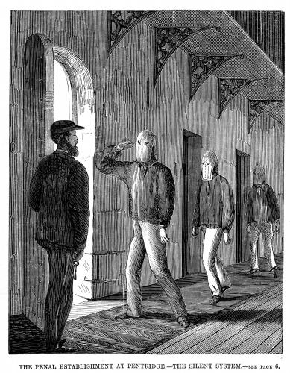
The separate and silent systems
- In the separate system prisoners were kept in individual cells where they worked, prayed and received religious teaching. This system was very expensive and had a high death rate with prisoners committing suicide or going insane. They were never allowed to see other prisoners. Prison reformers thought this would help prisoners to get work when released because they had done useful work in prison.
- In the silent system prisoners were allowed to spend time with one another but had to do so in silence so that they wouldn’t influence each other. This system relied on fear and hatred so conditions were as horrible as possible. They thought if they made the experience horrible people would never want to return to prison.
- 1865 Prisons Act concentrated on harsh punishments- summed up by ‘Hard labour (work), hard fare (food) and hard board (accommodation)’. The aim was to enforce strict punishment, not to reform.
- The 1877 Prisons Act ‘nationalised’ prisons under government control and everything was the same across all prisons.

How successful have methods of punishment in Wales and England been in the twentieth and twenty first centuries?

- Changing attitudes to punishment
  - (abolition of corporal and capital punishment; punishment as retribution or rehabilitation)
- Changes to imprisonment
  - (the use of borstals; young offenders institutes; open prisons; prisons today)
- Alternative methods to imprisonment
  - (suspended sentences; probation and parole; community service; tagging; current initiatives)

Changing attitudes to punishment
abolition of corporal and capital punishment
- Corporal Punishment
  - Use of pillory was abolished in 1837 and stocks no longer used after 1872. In 1948 whipping was no longer used. Public attitude turned against using pain to punish. Corporal punishment was made illegal in state schools in 1986.
- Capital Punishment
  - Opinions were often divided
For | Against
A dead murderer cannot kill again | The wrong person may be hanged
Hanging is the ultimate deterrent | Most murders are spur of the moment so hanging isn’t really a deterrent
Keeping a murdered in prison is expensive | Hanging is barbaric
Hanging satisfies the victims family and public | Even the worst person could be reformed
It protects police and prison staff | Other countries have abolished capital punishment and the crime rate hasn’t increased.

- Timothy Evans
  - Hanged for murdering his baby daughter in 1950. He had confessed to killing his wife accidentally and did confess to killing his daughter. Evans claimed he was threatened by the police and did change his statement several times. 3 years after he was hanged a serial killer was caught and confessed to the crime Evans had been convicted of.
- Derek Bentley
  - Hanged for his part in the murder of a police officer in 1953. As the person who actually killed him was only 16 he could not be hanged. Bentley is believed to have had learning difficulties and was only 19. He got a full pardon in 1998.
- Ruth Ellis
  - Last woman to be hanged in the UK. Convicted of killing her lover and hanged. It was believed to be a crime of passion and not pre-meditated.
- These cases all strengthened the argument for abolishing capital punishment. In 1957 the Homicide Act abolished hanging for all murders except;
  - Murder of a police officer
  - Murder by shooting or explosion
  - Murder while resisting arrest
- In 1965 the Murder Act was introduced for a trial period of 4 years. In 1969 it became official as the Abolition of the Death Penalty Act. The last hangings to happen were in 1964.
punishment as retribution or rehabilitation
- There is still a debate about whether prisons should be used to rehabilitate or for retribution.
- Nowadays there is more emphasis on rehabilitating offenders to prepare them to be law abiding citizens on the outside
Changes to imprisonment
the use of borstals
- Designed for juveniles – was meant to be educational rather than punishing. It had strict rules.
- The focus was on routine, discipline and authority.
- Research in the 1970s showed that the longer the inmates remained in a borstal the more likely they would be to reoffend when they were released.
- Borstals were abolished in 1982.
young offenders institutes
- Borstals were replaced with young offenders institutes in 1988.
- They house inmates who are 18-21 and are very similar to prisons but with a higher staff to inmate ratio.
- Their purpose is to reform through education (25hours a week).
- Offenders under 21 will be sent to a YOI or;
  - Secure Training Centre – up to the age of 17 and privately run. For vulnerable young people.
  - Local Authority Secure Children’s Homes – focus on the physical, emotional and behavioural needs of vulnerable young people.
  - Juvenile Prisons – for 15-18 year olds. There are three of them in England.
open prisons
- Set up after WW2 to relieve pressure on other prisons.
- Normally house non-violent inmates with a low risk of escaping.
- It has been criticised for its lax security – 70 inmates escaped in 2006 alone.
- Aim is to resettle prisoners into the community. Open prisons have been criticised for being a ‘soft option’ but they are much cheaper to run than closed prisons.
prisons today
- In 1985 there were 48,000 prisoners. By 2012 there were over 83,000.
- Prisons are divided into categories based on age, gender and the type of crime committed.
- Category A; Very dangerous to the public.
- Category B; People for who escape needs to be made difficult.
- Category C; Prisoners who can’t be trusted in open prison but who are unlikely to try to escape.
- Category D; Prisoners who can be reasonably trusted not to try and escape.
- Women in prison;
  - Female only prisons exist in England. Holloway Prison in London is the most famous. Currently there are no prisons in Wales for women.
Alternative methods to imprisonment
suspended sentences
- Used as an alternative to prison since 1967. The offender doesn’t go to prison unless they commit another crime in that time period.
probation and parole
- Probation service began in 1907 – offender has to follow a strict set of rules and keep in touch with the probation officer regularly.
- From 1982 offenders had to perform set activities and attend day centres.
- In 1967 the Parole Board was created. It means letting a prisoner out of jail before the end of their sentence. They can only get this if they have good behaviour reports and also depends on the type of crime committed.
- Once out of prison they are on ‘conditional release’ – if conditions of the licence are broken they will be recalled to prison.
community service
- Community Service Orders were introduced in 1972. Offenders have to do a certain number of hours of unpaid work for the community.
- More cost effective than probation. Very successful for older offenders but not really a deterrent on younger offenders.
- Since 2003 Community Service has become ‘Community Payback’. You can be sentenced to between 40 and 300 hours.
- Aim is to punish offenders without serving a prison sentence.
Tagging
- Introduced as an experiment between 1995 and 1997.
- A tracking device is fitted to the individual which uses GPS.
- If tagged prisoners can be released between 2 and 12 weeks early.
- It has proved quite effective so far.
current initiatives
- ‘Breaking the cycle: effective punishment, rehabilitation and sentencing of offenders’ was the government’s 2010 ideas on punishment. Ideas include;
  - Regular working hours in prison.
  - New measures to force criminals to make amends with victims.
  - Private companies would be rewarded for reducing re-offending.
- This reflects current attitudes to punishment and intends to make prisons ‘places of hard work’ in an attempt to reduce re-offending.

EXAM QUESTIONS

Question 1 PRACTICE: There will be four of these questions. They require one word answers, each is worth one mark, no technique required, you just need to know the answer!
Complete the sentence below with the most accurate term:
The most common cause of vagrancy in the 16th century was…
A wooden framework which confined petty criminals by the ankles and put them on public display was…
A vagabond who used a long wooden pole to steal items was called a …
During the Tudor period, the main law enforcement officer was the …
Between 1688 and 1815, over 225 crimes carried the death penalty and formed part of the ….Code
Tudor JPs were helped in their day to day policing duties by the parish…
A famous 18th century thief taker was Jonathan…
The main place of public execution in 18th century London was …
The system of punishment which involved banishment overseas was known as…
Henry Fielding was responsible for setting up the Bow Street…
The most famous highway robber of the 18th century was …
The desire to avoid the paying of customs duties during the 18th century resulted in the rise of…
The Newport rising took place in 18…
During the first half of the 19th century, the trend in crime levels was…
Industrialisation was a cause of increased crime during the ………. century
Transportation as a punishment was finally ended in 18…
Drivers suspected of drink driving are required to breathe in to a …
A type of prison for young offenders which was opened in 1902 was called…
The first women police officers came in to service in 19…
In 2017, the number of separate police forces was…
In 1901, Sir Edward Henry was responsible for introducing…

Question 2 PRACTICE: Look at the three sources below which show different types of crime over time and answer the question that follows.
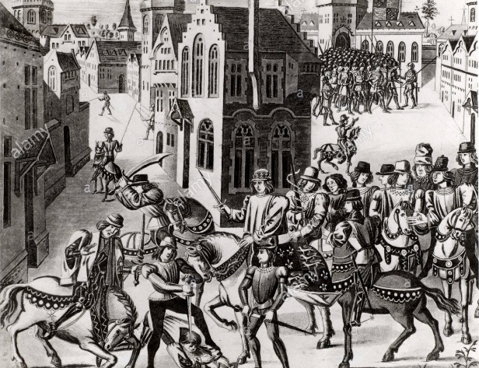
SOURCE A

[The Peasant’s Revolt of 1381]
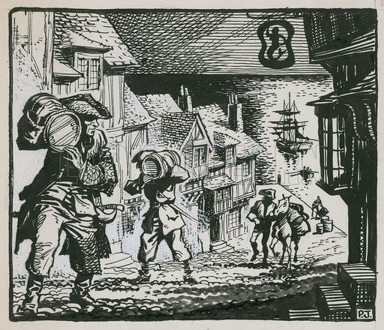
SOURCE B:

[English Smugglers in the 17th century]
SOURCE C:
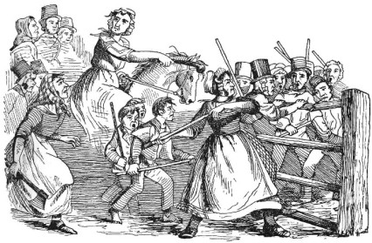

[The Rebecca Riots 1843]

TIPS:
Refer to all 3 sources. Find one similarity and explain it thoroughly using your knowledge. Find one difference and do the same

Use Sources A, B and C to identify one similarity and one difference in the causes of crime over time. [4]
Sources A and C are both similar in that they show protests over time. The Peasant’s Revolt of 1381 was a rebellion in response to the government introducing a poll tax and the Rebecca Riots of 1843 was also a rebellion against high taxes as well as the introduction of toll-gates. Source B is different in that, although smuggling could also be seen as a response to high taxes on items such as tea and sugar, it was mainly motivated by greed as there was a lot of money to be made. It was also not an outright rebellion.

NOW YOU TRY…

1. Use Sources A, B and C to identify one similarity and one difference in the methods of enforcing law and order over time. [4]
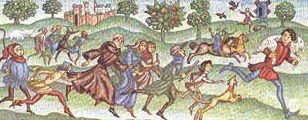
SOURCE A
A 16TH century image entitled ‘Chasing the Sheep Stealer’

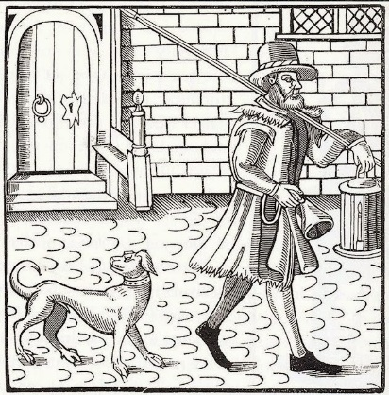
SOURCE B
A watchman in the 1600s

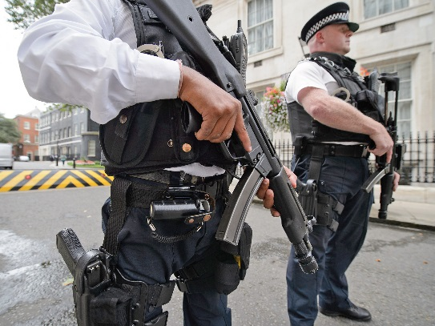
SOURCE C
A 20th century image of the modern police force

2. Use Sources A, B and C to identify one similarity and one difference in the attitudes to crime and punishment over time. [4]
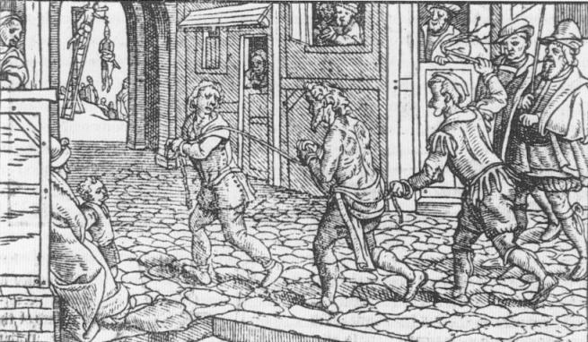
SOURCE A
A vagabond being punished in the 1530s

SOURCE A

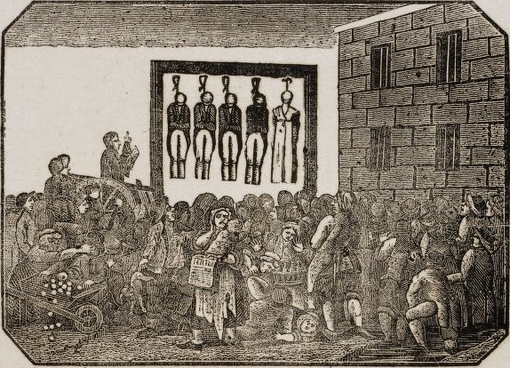
SOURCE B
A public hanging in the 1600s

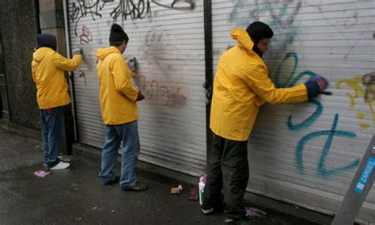

SOURCE C
Offenders completing community service in the 21st century

4. Use Sources A, B and C to identify one similarity and one difference in the methods of punishment over time. [4]
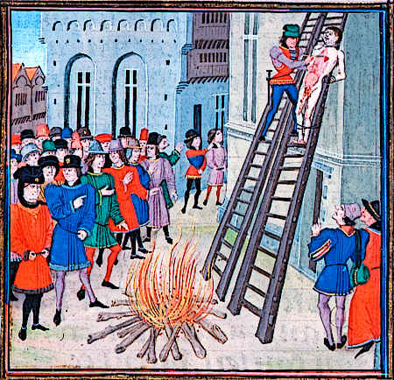
SOURCE A
A 16th century painting of a criminal being hung, drawn and quartered

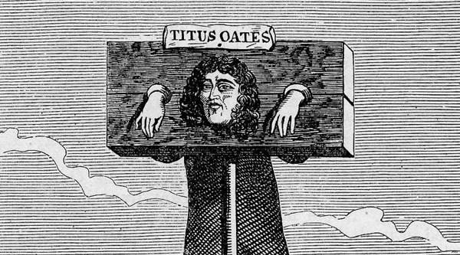
SOURCE B
Engraving of Titus Oates, being punished in the pillory, 1685

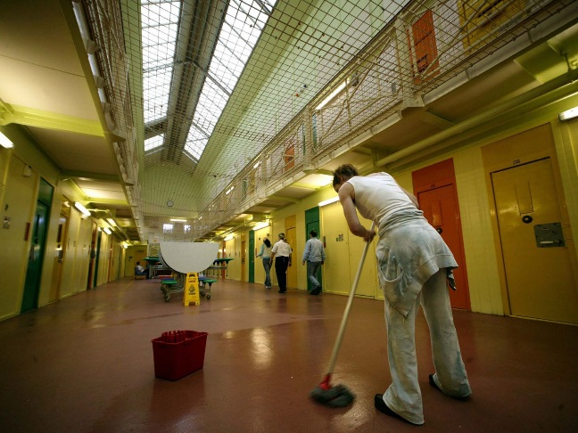
SOURCE C
Image of a prison in Wakefield, 2003

5. Use Sources A, B and C to identify one similarity and one difference in the nature of criminal activity over time. [4]

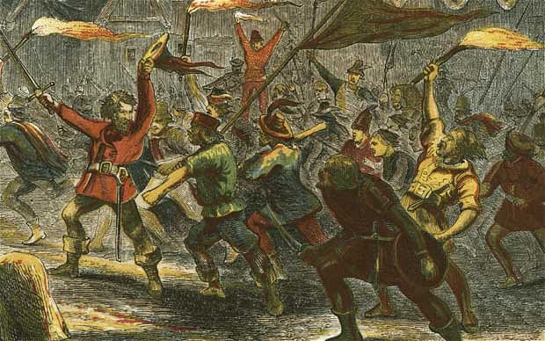
SOURCE A
An artist’s impression of Jack Cade’s Revolt, 1450

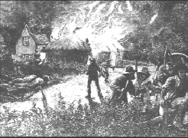

SOURCE B
A contemporary drawing of the Swing Riots, 1830

SOURCE C
An example of a modern ‘phishing’ email

Question 3 and 4 PRACTICE: Describe… [6]

Straightforward knowledge question! Aim for very detailed and accurate knowledge. You have 15 lines; aim to fill them all

Describe the role of George O. Paul in the prison reform movement [5]
TIP: Be specific. Use key dates, statistics and historical key words.

Paul wrote a report called ‘Thoughts on the Alarming Progress of Gaol Fever’ in 1784 and devised a reform system for a new type of prison. He built a new prison in Gloucester with a 5 metre high wall for security. He called for isolation wards to stop diseases spreading and an exercise yard to keep prisoners healthy. Males and females were separated and prisoners were to be reformed through work, education and religion. Prisoners were taught to read from religious books. His work was highly influential in the building of other newly reformed prisons.

NOW YOU TRY:

- Describe the role of a Tudor JP in combating crime [6]

- Describe the different types of vagabonds in the sixteenth century. [6]

- Describe highway robbery [6]

- Describe the Rebecca Riots [6]

- Describe the rise of cybercrime in the twentieth century [6]

- Describe the growth of crimes associated with drugs in the twentieth century [6]

- Describe the threat of modern terrorism [6]

- Describe the methods of combatting crime in 16th and 17th century [6]

- Describe the role of the Bow Street Runners in the 18th century [6]

- Describe the role of the Night Watchman in the Tudor and Stuart period [6]

- Describe the work of the Fielding brothers [6]

- Describe the main features of the 1829 Metropolitan Police Act [6]

- Describe changes to the police force in the nineteenth century [6]

- Describe the developments in transport and communication used by the police force in the twentieth and twenty-first centuries [6]

- Describe the increasing use of forensic science in the modern police force [6]

- Describe the work of John Howard in prison reform [6]

- Describe the work of Elizabeth Fry in prison reform [6]

- Describe how young offenders are dealt with in the twentieth century onwards [6]

- Describe alternatives to prison used in the modern era [6]

- Describe how prisons changed in the twentieth century [6]

Question 5 PRACTICE: Explain why… [12]
TIP: The key word here is WHY. You need to give at least 3-4 reasons as to why something happened and explain them in detail.

Explain why opportunities for crime increased by the end of the eighteenth century

Crime increased in the eighteenth century largely due to the increasing opportunities created by the development of the commerce, trade and industry of the country. Towns filled up because the introduction of machinery in farming meant there were fewer jobs in the countryside so workers flooded in to the towns to work in factories. Over crowding led to opportunities for crimes such as pickpocketing which increased hugely.
Another example of crime which increased was highway robbery. This increased because more wealth and money was transported due to increasing trade. There were many vulnerable, open areas outsides towns; handguns became easier to purchase and horses were easy to obtain. Parish constables found it difficult to chase highwaymen
A further example was an increase in smuggling. This increased as a direct result of government taxation. Smugglers avoided paying the excise and could make money selling goods at a cheaper rate. Large areas of the south and west of the country were economically depressed at times and some people resorted to smuggling to survive.

NOW YOU TRY

Explain why there were more crimes linked to poverty in the sixteenth century. [12]

Explain why there was a rise in crimes associated with religion in the sixteenth century. [12]

Explain why there was a rise in the crime of smuggling in the eighteenth century. [12]

Explain why there was a rise in crimes linked to urbanisation in the nineteenth century [12]

Explain why there was a rise in motoring crimes in the twentieth century [12]

Explain why many people opposed the setting up of the Metropolitan Police in 1829 [12]

Explain why punishments were harsh in the Tudor and Stuart period [12]

Explain why transportation was introduced in the eighteenth century [12]

Explain why there was need for reform of the Criminal Code in the nineteenth century [12]

Explain why there was more attempt to reform prisons from the mid-nineteenth century [12]

Explain why capital punishment was abolished in 1969 [12]

Question 6 PRACTICE: Explain why ….was significant in… [12]

Explain why areas such as ‘China’ in 19th century Merthyr were significant in causing a rise in crime in the early 19th century [12]
TIP: The key word here is SIGNIFICANT. You need to give at least 3-4 reasons as why something was significant and explain them in detail.

KEY POINTS: Sometimes this question will use the word ‘effective, successful or important
Sometimes the word ‘how’ may be used instead of why…this does not mean a debate is required. THIS IS NOT A TWO SIDED ANSWER

The Industrial Revolution resulted in the development of factories and the growth of towns were sited. In the case of Merthyr, it population gre dramatically from just over 7,700 in 1801 to over 46,000 by 1851, making it the largest industrial town in Wales. This was significant in causing crime because the number of houses which needed to be built were packed close together and without proper hygiene. This meant that people were living in squalor, poverty and disease which meant they turned to crime.
Keep to the question, explain significance, don’t describe

Another reason the growth of Merthyr was significant in causing crime was because of wage reduction and regulation. Most of the workers worked in the ironworks or coal mines and were paid in tokens which could only be spent at the company Truck shops which charged higher prices. This meant that workers were forced to get in to debt and were therefore turning to crime to survive. This was worse when workers were laid off at times of depression which was common in Merthyr in the 19th century and made people turn to crime.

A further reason that the growth of Merthyr was significant was the fact that the availability of food depended on a good harvest in the countryside but when this did not happen, food prices would rise and there was rioting and shops were looted. There was no proper police force to control this and therefore crime was common in Merthyr and other industrial towns like Cardiff in the 19th century.
Use key facts and dates to support your points
The growth of the towns was significant because it was so fast and there was no time for law enforcement to keep up. The old system of JPs and parish constables just could not cope. Places like China became a haven for criminals and even when in 1841, a police force was organised, they could not enter places like China as they were afraid of the organised crime gangs which were ruled over by the ‘Emperor’ and ‘Empress’. This meant that crime went unchecked.
Make a judgement which answers the original question. This does not have to be balanced though
Overall, the rapid and uncontrolled growth of towns like Merthyr and the poverty and degradation of their inhabitants, coupled with the lack of effective law enforcement, meant that crime was rife in the early 19th century.

NOW YOU TRY:

Why was the development of technology important in causing new types of crime in the late twentieth and early twenty-first centuries? [12]

Why was the development of police specialisation significant in combating crime in the twentieth and twenty-first centuries? [12]

Why was the introduction of alternative methods of punishment to imprisonment significant in the twentieth and twenty-first centuries? [12]

How important was the development of the motor car in causing new types of crime in the twentieth century? [12]

How important was the use of technology in improving policing methods in the twentieth century? [12]

How significant was the development of transportation as a method of punishment? [12]

Why was the Industrial Revolution significant in causing crime in the early nineteenth century? [12]

Why was the work of prison reformers important in the eighteenth and nineteenth centuries? [12]

Why were changing attitudes important in the abolition of the death penalty in the 20th century? [12]

Why was the reformation important in causing crime in the 16th century? [12]

This is the essay question. There are 4 marks for spelling and grammar. There are 6 possible outlines questions you can be asked. It’s worth writing essay plans and practicing all of them. You must include reference to Wales

Question 7 PRACTICE: To what extent has… changed over time [16 + 4 marks]
To what extent has poverty been the main cause of crime over time?
Keep to the question, explain causes, don’t describe
In the early modern era, under the Tudors and Stuarts, poverty was a key cause of rising crime. The population growth, poor harvests in the 1550s and 1590s and the dissolution of the monasteries under Henry VIII led to a higher percentage of poor people, many of whom became vagrants. In Wales, poverty meant that there was many food riots in the Welsh marches. One change in this period was the increase in crimes associated with religion. This was because changing government policy influenced the crime rates. For example, more people were burnt at the stake for heresy (283 Protestants were executed under Mary I). John Penry was an example of a welsh martyr Linked to this, the number of crimes for treason increased. The Popish Plot of 1678 and the Gunpowder Plot of 1605 were both caused by religious motives.
Use key facts and dates to support your points

Economic hardship continued to cause new crimes such as smuggling on the Welsh coast in the years 1700 – 1900, although this was also caused by government policies and inadequate policing because people were prepared to take the risk given the high prices of goods. In the 19th century, a new change in the causes of crime was the process of urbanisation. Heavy concentrations of people living in urban areas such as Cardiff and Merthyr, led to more opportunities for petty crime. The Industrial Revolution also saw a continuation of crimes linked to economic hardship such as pickpocketing and theft and a continuation of protests against the government for example the Luddites and the Rebecca Riots in Wales.
Show change as well as continuity

In the twentieth century, poverty has continued to be a motivation for crime. Many people see this as a reason for an increase in gun and knife crime and juvenile gang culture. Crimes such as terrorism may be new but they could be seen as a continuation of protests against the government for example, the bombing of Manchester in 1996 by the IRA was a political protest against British policies in Northern Ireland, while the Meibion Glyndwr carried out arson attacks in Wales. However, a huge change can be seen in the way that many crimes are now caused by drugs. The Dangerous Drugs Act of 1920 made possession of drugs illegal and drug gangs often use violence to protest their ‘turf’. Additionally, drug addiction is a major factor in the increase of crimes such as muggings and robbery. The invention of new technology has also caused an increase in crime for example the invention of computers has led to a rise in cybercrimes such as hacking.
Write a conclusion which answers the original question.
Don’t run out of time and forget to write about the modern era. You will lose a lot of marks

In conclusion, although there have been other causes of crime which have been important at different times in history, such as religion in the 15th and 16th century, these have come and gone. The main cause of crime which has been present more or less constantly from Tudor times to the modern era is poverty. This has fuelled crimes such as theft and burglary for centuries. Government policy has also been a cause of crimes such as protests and rebellions, a common theme in every era. The twentieth century onwards, however has seen the biggest change in the cause of crime with new technology leading to different, more complex crimes.

NOW YOU TRY

To what extent has criminal activity changed over time? (this question may name a type of crime and ask whether that has remained the main type of crime over time) [16+4]

To what extent has the responsibility of enforcing law and order changed over time? [16+4]

To what extent have the actions of private individuals been the main method of combating crime over time? [16+4]

To what extent have changes in social attitudes been the main reason for changes in punishment over time? [16+4]

To what extent has prison been the main method of punishment over time? [16+4]

