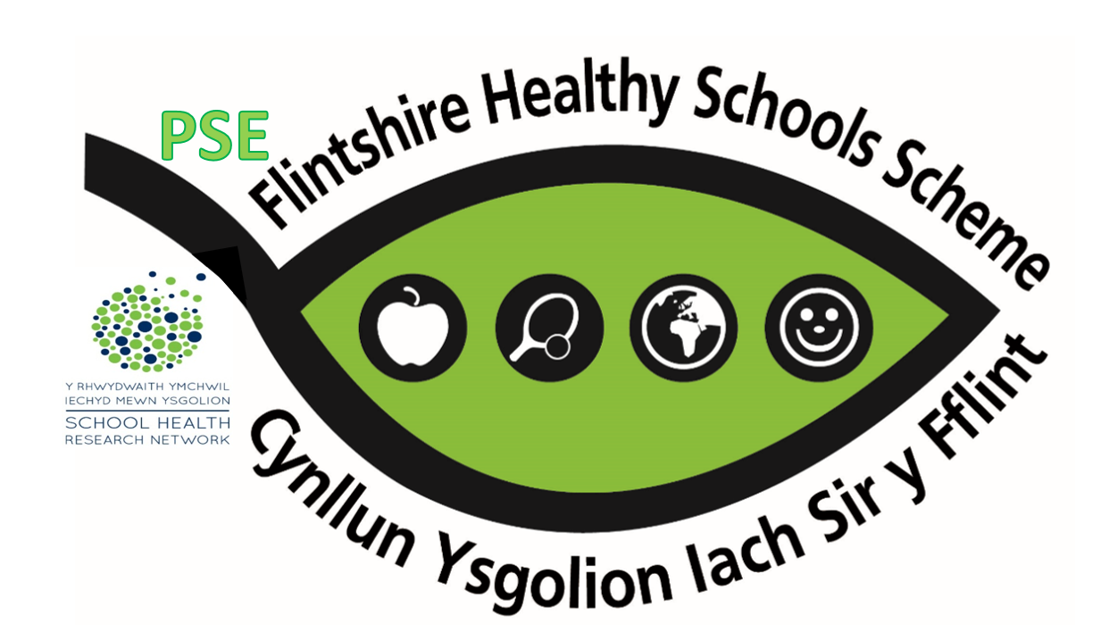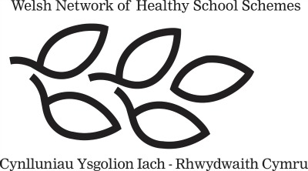

At Hawarden High School we engage in the Welsh Network of Healthy Schools Scheme.

A ‘Healthy School’ is one which takes responsibility for maintaining and promoting the health of all who ‘learn, work, play and live’ within it not only by formally teaching pupils about how to lead healthy lives but by enabling pupils and staff to take control over aspects of the school environment which influence their health.

We joined the scheme in 2007 and achieved Phase 5 in December 2017, after working on the following themes:
Food & Fitness
Safety
Hygiene
Substance Use & Misuse
Environment

The current themes we are focusing on for Phase 6 are:
Emotional & mental heal and wellbeing
Personal Development & Relationships

We are committed to actively promoting, protecting and embedding the physical, mental and social health and well-being of our community through positive action.

The completion of Phase 6 involves a two day National Quality award visit from verifiers on June 26th & 27th June 2019.

